**EXERCISE 1:**

**public** **class** simple {

/**

* **@param** args

*/

**public** **static** **void** main(String[] args) {

// **TODO** Auto-generated method stub

System.*out*.println("Hello ilakiya");

}

}

**OUTPUT:**

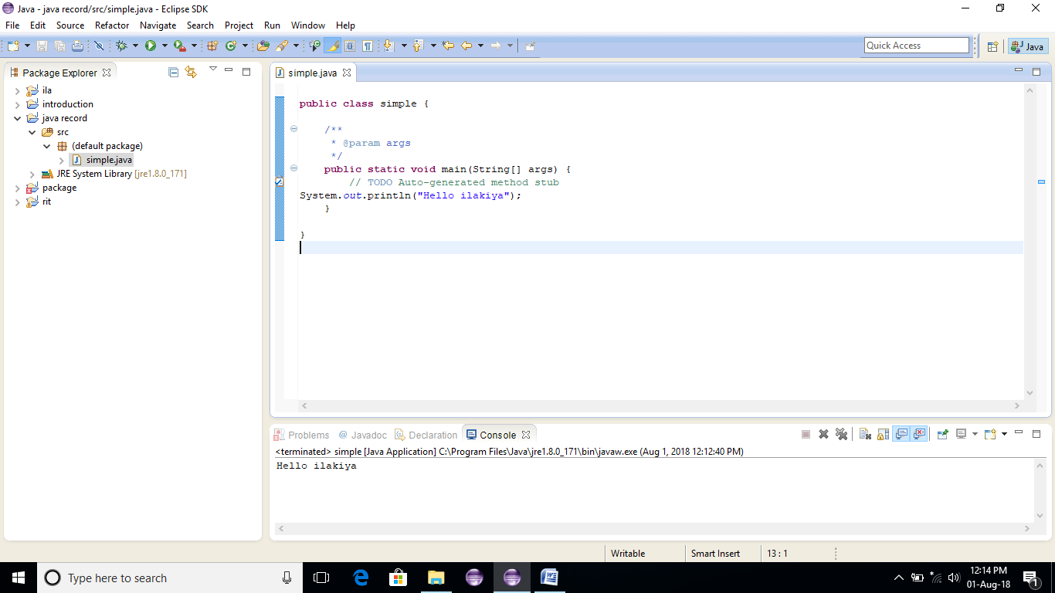

**RESULT:**

**EXERCISE 2:**

**public** **class** student1 {

**int** id;//data member

String name;

**public** **static** **void** main(String[] args) {

student1 s1=**new** student1();

System.*out*.print(s1.id);

System.*out*.print(s1.name);

}

}

**OUTPUT:**

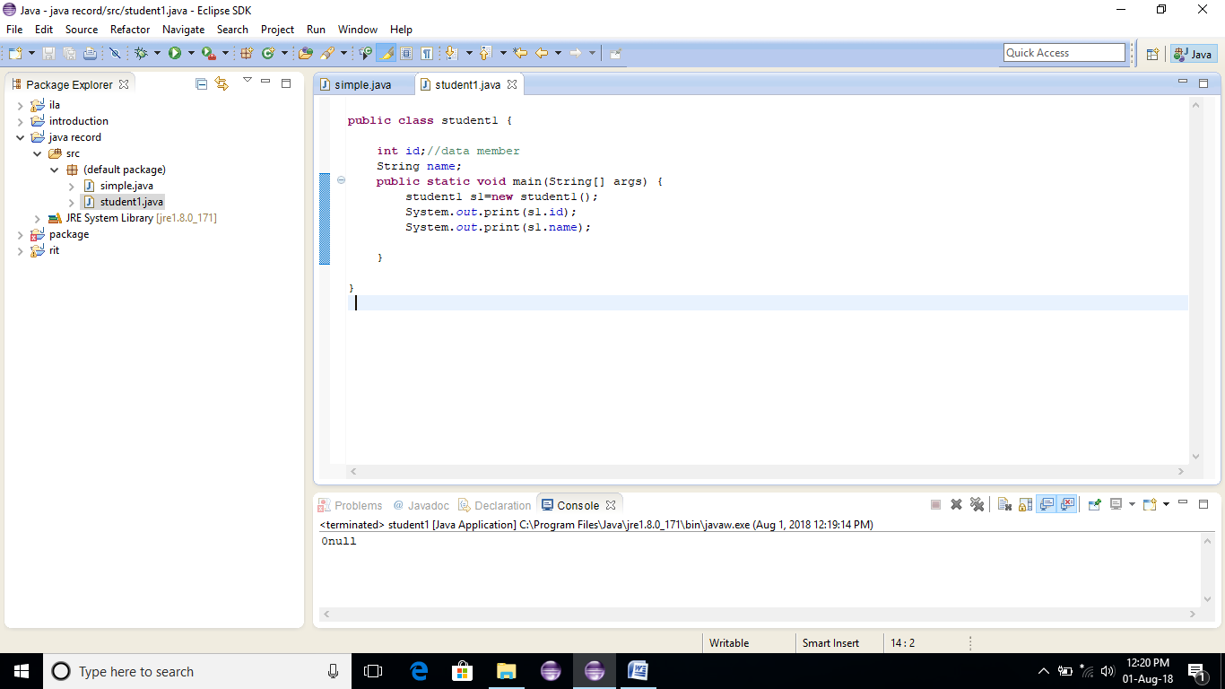

**RESULT:**

**EXERCISE 3:**

**public** **class** student2 {

**int** rollno;

String name;

**void** insertrecord(**int** r,String n){

rollno=r;

name=n;

}

**void** displayinformation(){

System.*out*.println(rollno+""+name);

}

**public** **static** **void** main(String[] args) {

student2 s1=**new** student2();

student2 s2=**new** student2();

s1.insertrecord(111,"ilakiya");

s2.insertrecord(112,"kirubu");

s1.displayinformation();

s2.displayinformation();

}

}

**OUTPUT:**

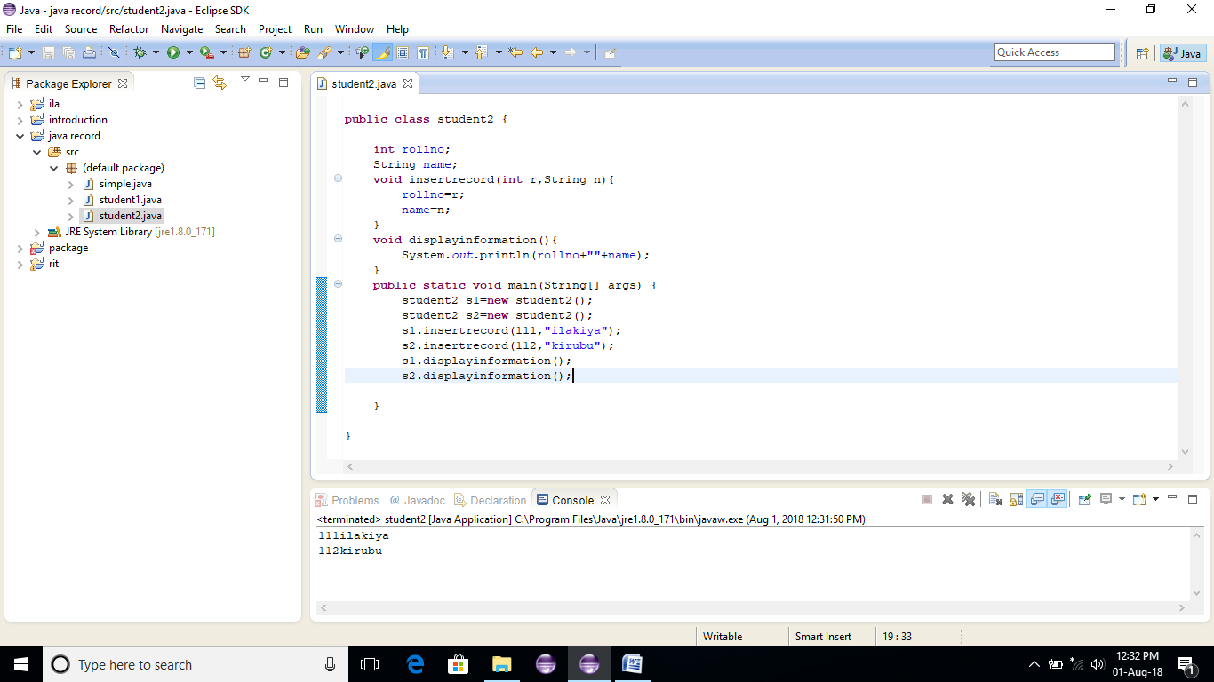

**EXERCISE4:**

**public** **class** ex4 {

**int** length;

**int** width;

**void** insert(**int** l,**int** w){

length=l;

width=w;

}

**void** calculatearea()

{

System.*out*.println(length*width);

}

**public** **static** **void** main(String[] args) {

ex4 r1=**new** ex4();

ex4 r2=**new** ex4();

r1.insert(15, 20);

r2.insert(25, 38);

r1.calculatearea();

r2.calculatearea();

}

}

**OUTPUT:**

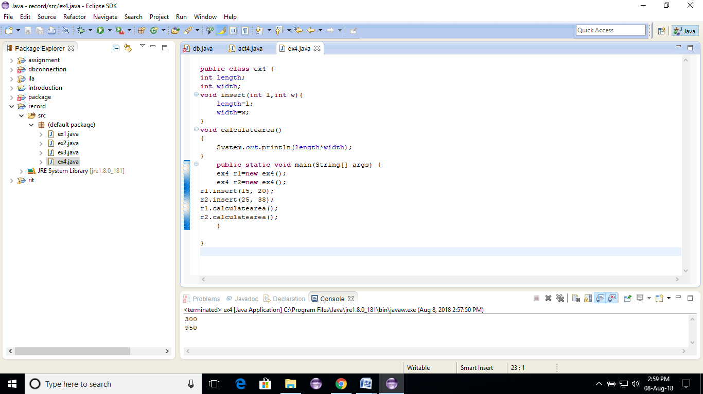

**RESULT:**

**EXERCISE 5:**

**public** **class** ex5 {

**void** fact(**int** n){

**int** fact=1;

**for**(**int** i=1;i<n;i++)

{

fact=fact*i;

}

System.*out*.println("the factorial is:"+fact);

}

**public** **static** **void** main(String[] args) {

**new** ex5().fact(10);//calling method with anonymous object

}

}

**OUTPUT:**

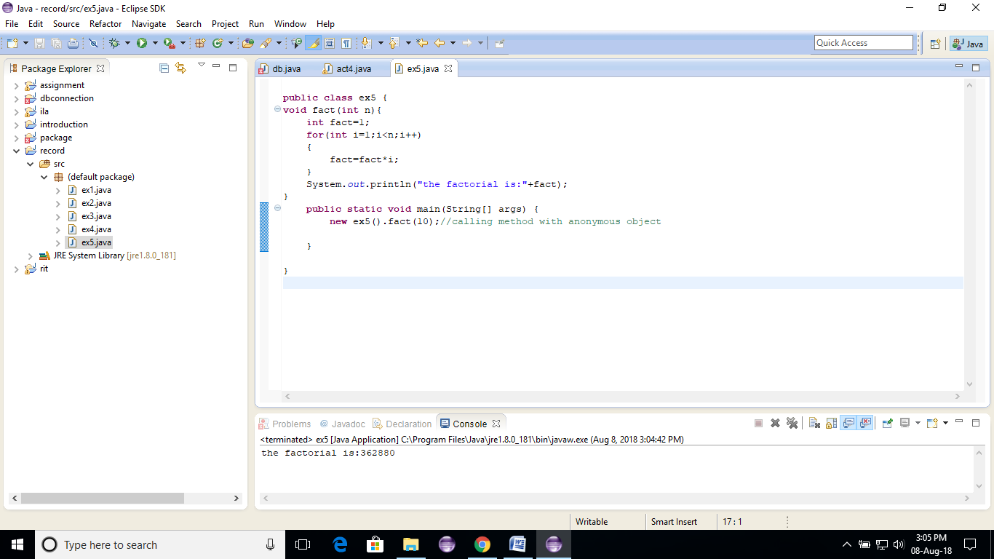

**RESULT:**

**EXERCISE 6:**

**public** **class** ex6 {

**int** length;

**int** width;

**void** insert(**int** l,**int** w)

{

length=l;

width=w;

}

**void** area()

{

System.*out*.println(length*width);

}

**public** **static** **void** main(String[] args) {

ex6 r1 = **new** ex6(),r2=**new** ex6();//creating two objects

r1.insert(30,45);

r2.insert(30, 20);

r1.area();

r2.area();

}

}

**OUTPUT:**

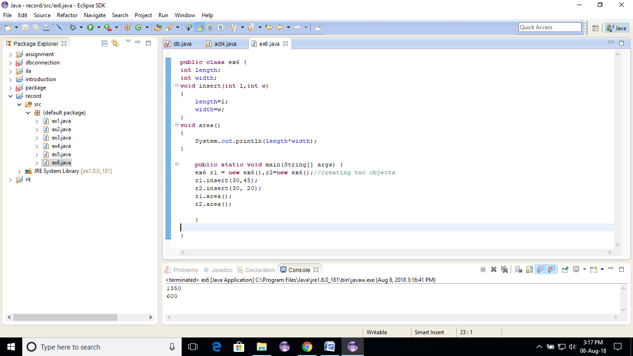

**RESULT:**

**EXERCISE 7:**

**public** **class** ex7 {

**void** sum(**int** x,**int** y){

System.*out*.println(x+y);

}

**void** sum(**int** x,**int** y,**int** z)

{

System.*out*.println(x+y+z);

}

**public** **static** **void** main(String[] args) {

ex7 s=**new** ex7();

s.sum(15,25);

s.sum(67,76,78);

}

}

**OUTPUT:**

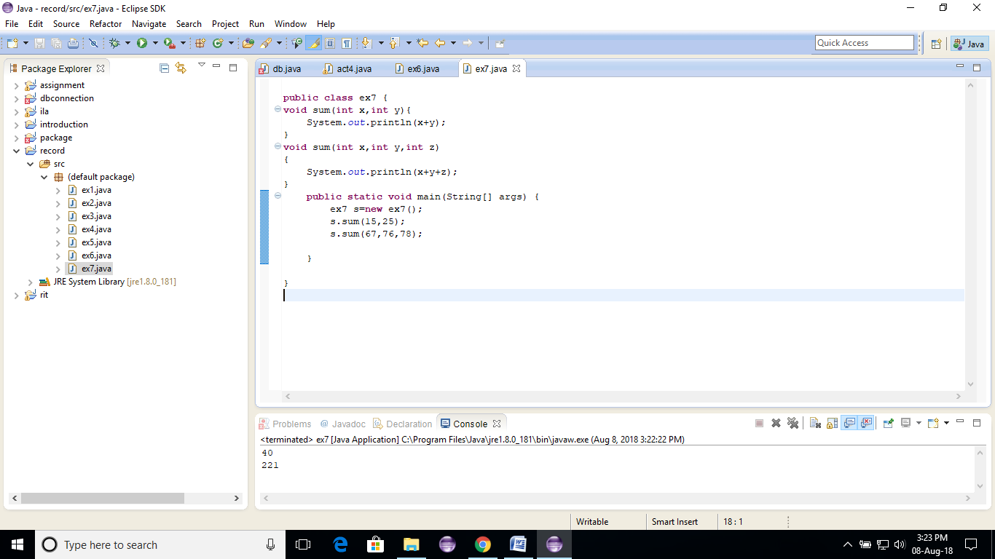

**RESULT:**

**EXERCISE 8:**

**public** **class** ex8 {

**void** sum(**int** x,**int** y){

System.*out*.println(x+y);

}

**void** sum(**double** x,**double** y,**double** z)

{

System.*out*.println(x+y+z);

}

**public** **static** **void** main(String[] args) {

ex8 s=**new** ex8();

s.sum(150,250);

s.sum(67.56,76.23,20.5);

}

}

**OUTPUT:**

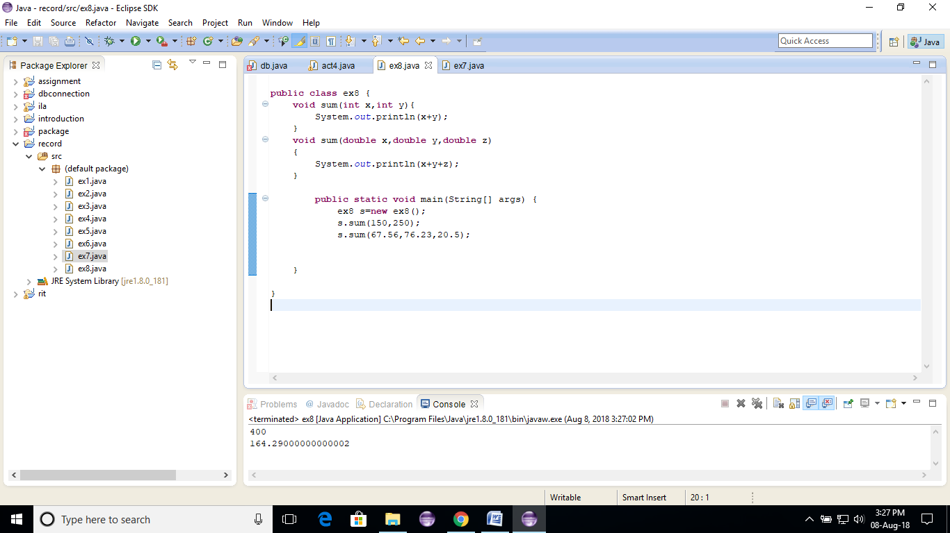

**RESULT:**

**EXERCISE 9:**

**public** **class** ex9 {

**public** **static** **void** main(**int** a)

{

System.*out*.println(a);

}

**public** **static** **void** main(String[] args) {

System.*out*.println("main() method invoked");

*main*(20);

}

}

**OUTPUT:**

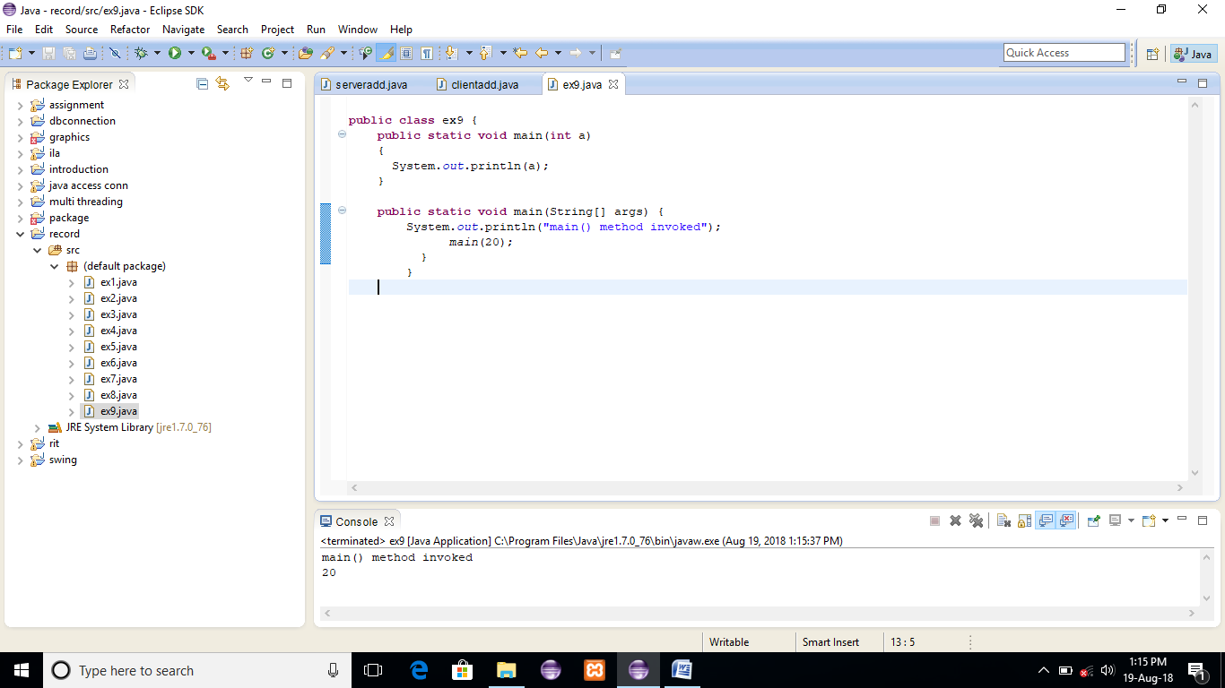

**RESULT:**

**EXERCISE 10:**

**public** **class** ex10 {

**void** sum(**int** a,**long** b){

System.*out*.println(a+b);

}

**void** sum(**int** a,**int** b,**int** c){

System.*out*.println(a+b+c);

}

**public** **static** **void** main(String[] args) {

ex10 obj=**new** ex10();

obj.sum(15,50);

obj.sum(150,150,100);

}

}

**OUTPUT:**

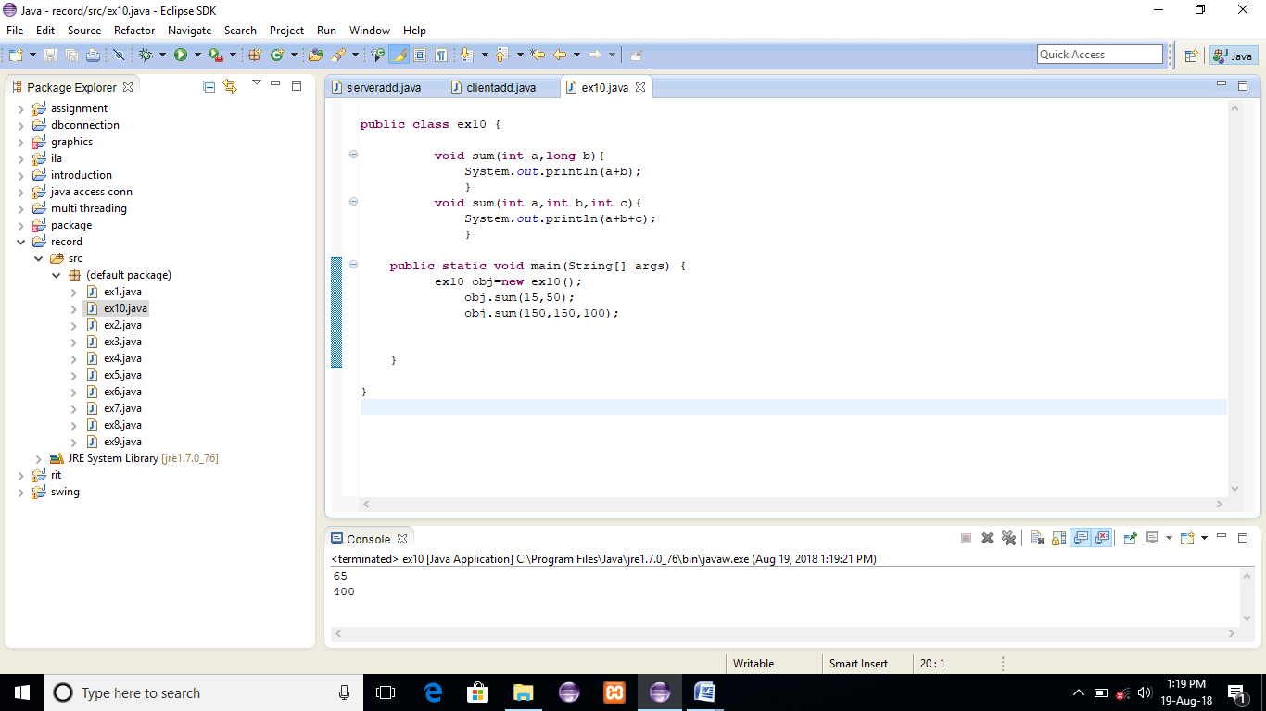

**RESULT:**

**EXERCISE 11:**

**public** **class** ex11 {

ex11(){

System.*out*.println("Bike is created");

}

**public** **static** **void** main(String[] args) {

ex11 b=**new** ex11();

}

}

**OUTPUT:**

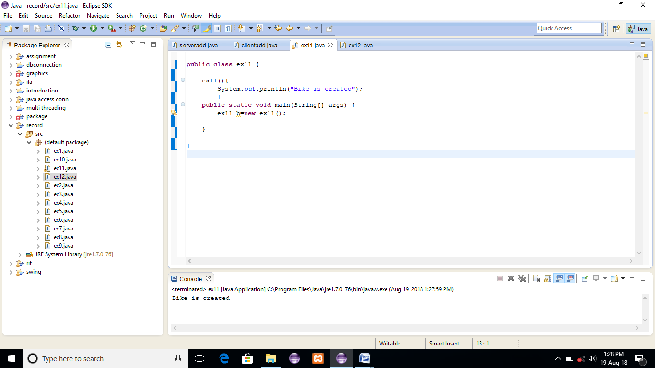

**RESULT:**

**EXERCISE 12:**

**public** **class** ex12 {

**int** id;

String name;

**void** display()

{

System.*out*.println(id+" "+name);

}

**public** **static** **void** main(String[] args) {

ex12 s1=**new** ex12();

ex12 s2=**new** ex12();

s1.display();

s2.display();

}

}

**OUTPUT:**

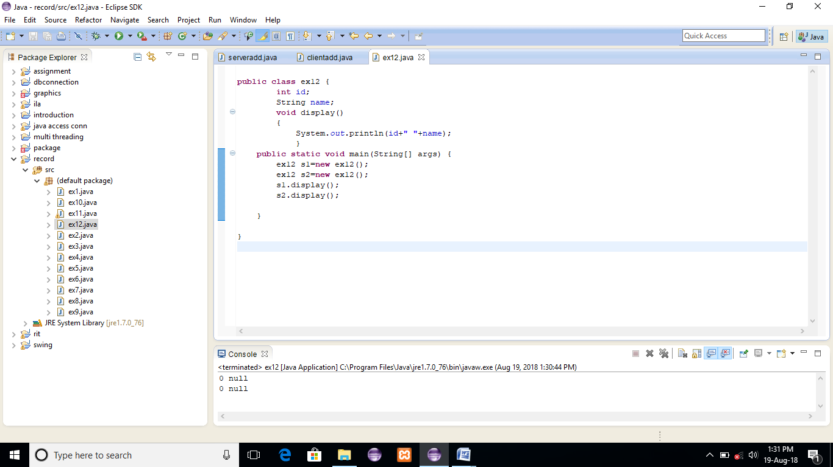

**RESULT:**

**EXERCISE 13:**

**public** **class** ex13 {

**int** id;

String name;

ex13(**int** i,String n){

id = i;

name = n;

}

**void** display(){System.*out*.println(id+" "+name);}

**public** **static** **void** main(String[] args) {

ex13 s1 = **new** ex13(100,"Kirubu");

ex13 s2 = **new** ex13(144,"Aisha");

s1.display();

s2.display();

}

}

**OUTPUT:**

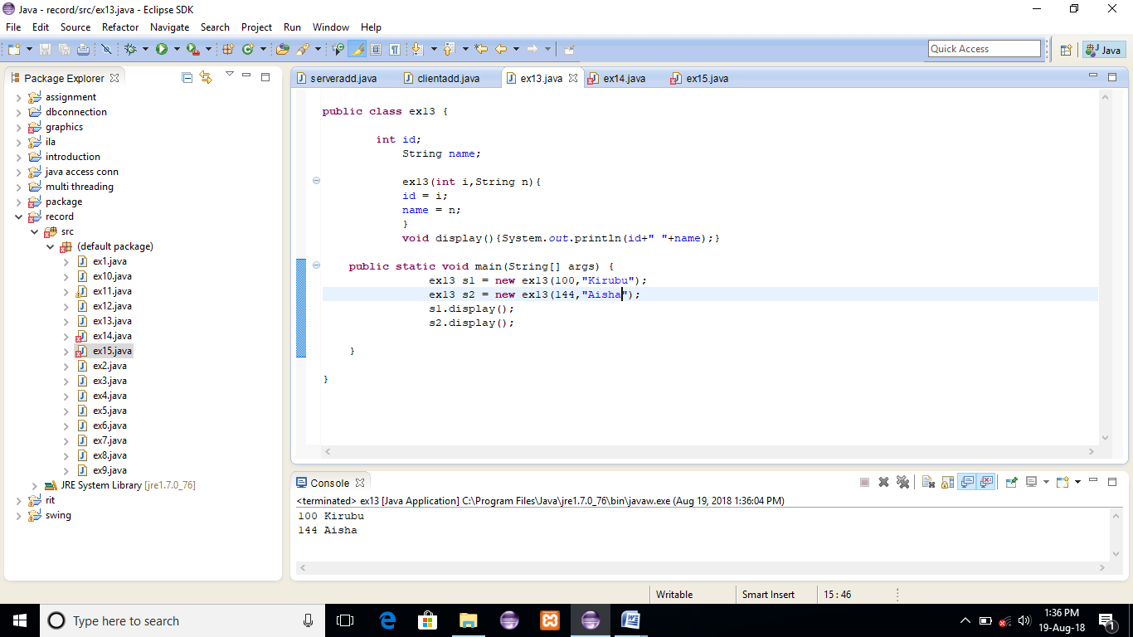

**RESULT:**

**EXERCISE 14:**

**public** **class** ex14 {

**int** id;

String name;

**int** age;

ex14(**int** i,String n){

id = i;

name = n;

}

ex14(**int** i,String n,**int** a){

id = i;

name = n;

age=a;

}

**void** display(){System.*out*.println(id+" "+name+" "+age);}

**public** **static** **void** main(String[] args) {

ex14 s1 = **new** ex14(111,"Kirubu");

ex14 s2 = **new** ex14(222,"Ashwini",25);

s1.display();

s2.display();

}

}

**OUTPUT:**

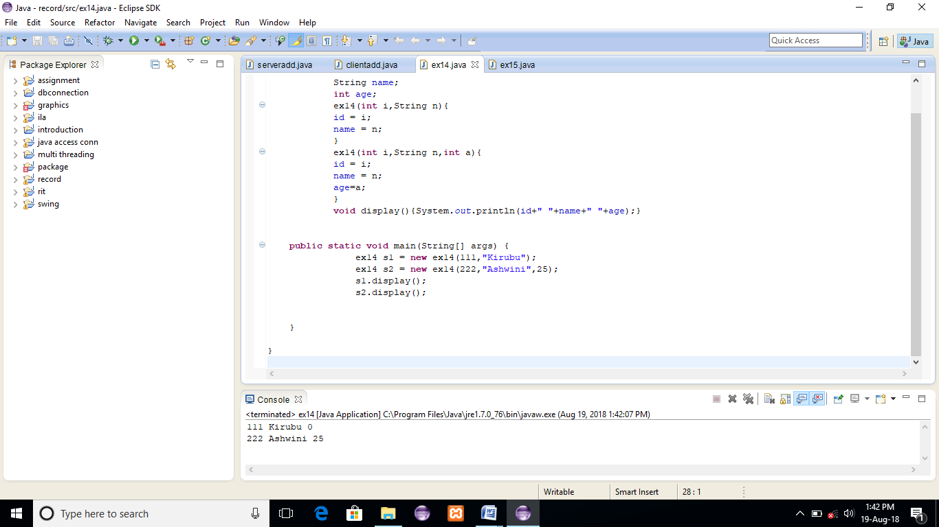

**RESULT:**

**EXERCISE 15:**

**public** **class** ex15 {

**int** id;

String name;

ex15(**int** i,String n){

id = i;

name = n;

}

ex15(ex15 s){

id = s.id;

name =s.name;

}

**void** display(){System.*out*.println(id+" "+name);

}

**public** **static** **void** main(String[] args) {

ex15 s1 = **new** ex15(104,"Kirubaraj");

ex15 s2 = **new** ex15(s1);

s1.display();

s2.display();

}

}

**OUTPUT:**

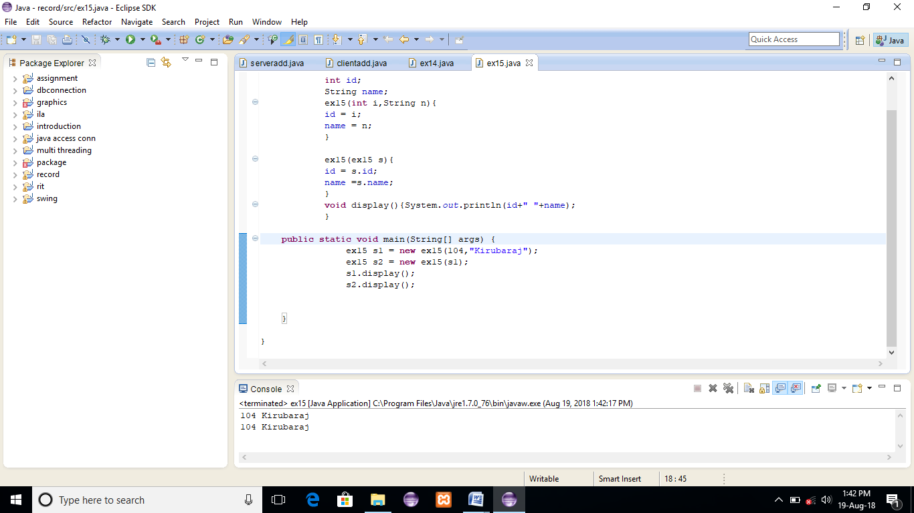

**RESULT:**

**EXERCISE 16:**

**public** **class** ex16 {

**int** count=0;//will get memory when instance is created

ex16(){

count++;

System.*out*.println(count);

}

**public** **static** **void** main(String[] args) {

ex16 c1=**new** ex16();

ex16 c2=**new** ex16();

ex16 c3=**new** ex16();

}

}

**OUTPUT:**

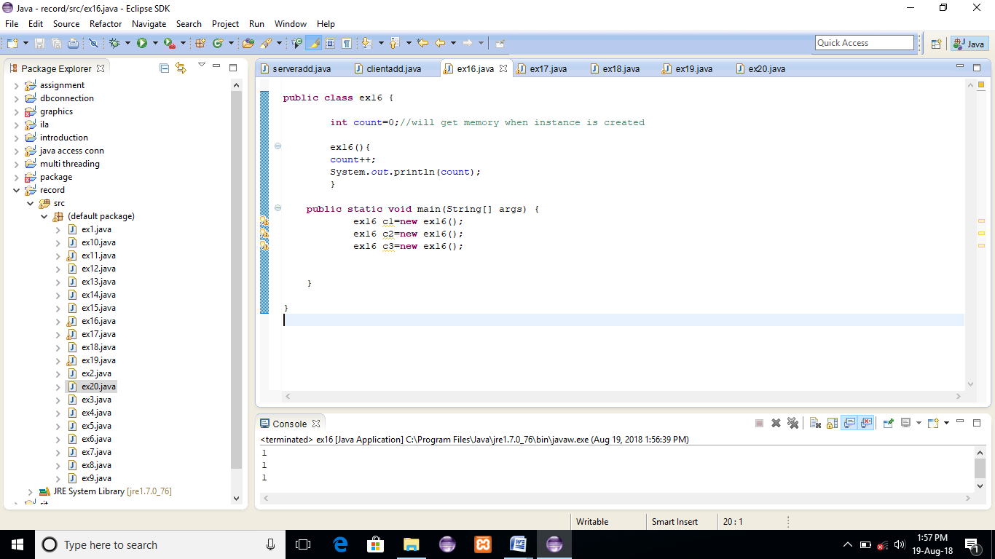

**RESULT:**

**EXERCISE 17:**

**public** **class** ex17 {

**static** **int** *count*=0;//will get memory only once and retain its value

ex17(){

*count*++;

System.*out*.println(*count*);

}

**public** **static** **void** main(String[] args) {

ex17 c1=**new** ex17();

ex17 c2=**new** ex17();

ex17 c3=**new** ex17();

}

}

**OUTPUT:**

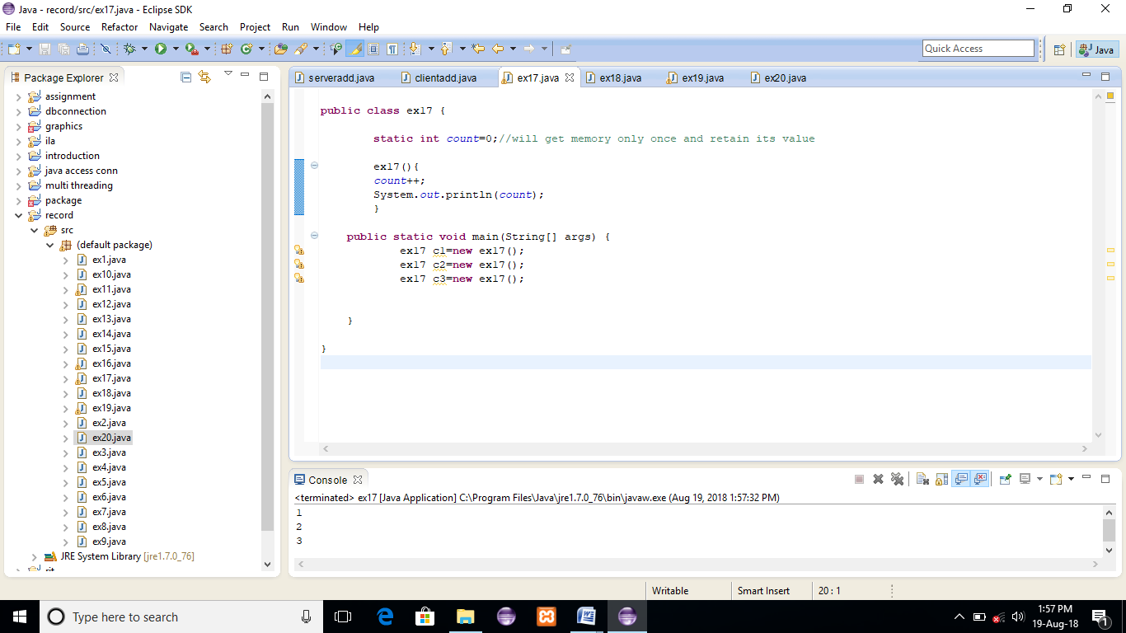

**RESULT:**

**EXERCISE 18:**

**public** **class** ex18 {

**int** rollno;

String name;

**static** String *college* = "ITS";

**static** **void** change(){

*college* = "BBDIT";

}

ex18(**int** r, String n){

rollno = r;

name = n;

}

**void** display (){System.*out*.println(rollno+" "+name+" "+*college*);}

**public** **static** **void** main(String[] args) {

ex18.*change*();

ex18 s1 = **new** ex18 (111,"ravindar");

ex18 s2 = **new** ex18 (222,"ilakiya");

ex18 s3 = **new** ex18 (333,"Priya");

s1.display();

s2.display();

s3.display();

}

}

**OUTPUT:**

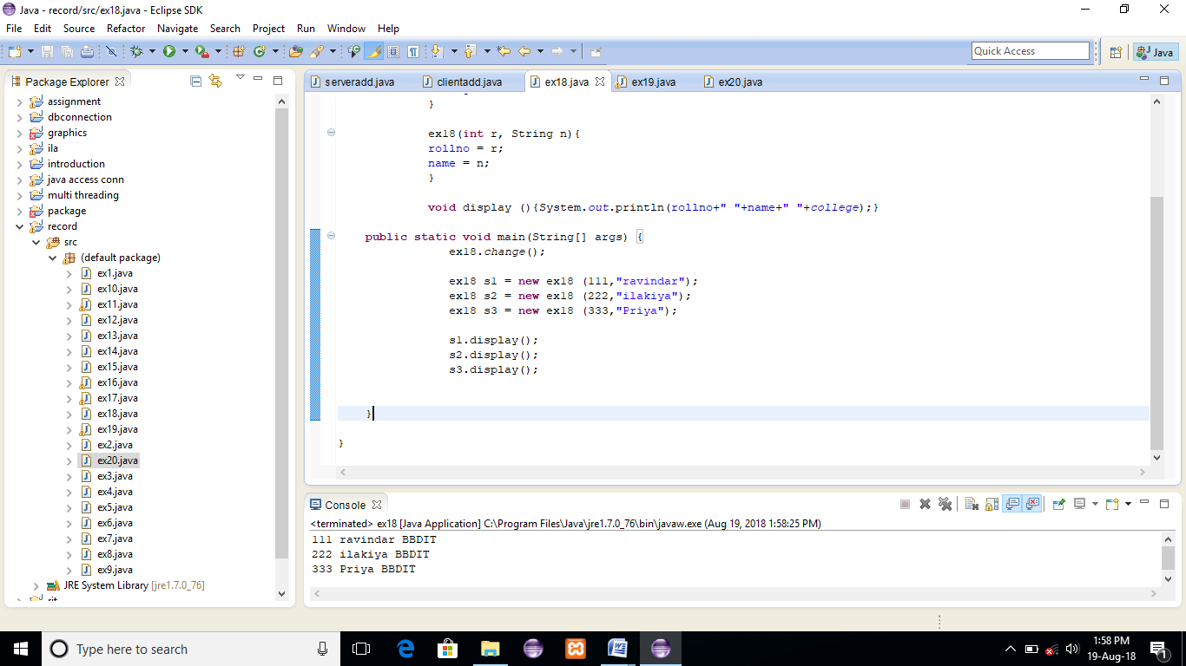

**RESULT:**

**EXERCISE 19:**

**public** **class** ex19 {

**int** id;

String name;

ex19(**int** id,String name){

id = id;

name = name;

}

**void** display(){

System.*out*.println(id+" "+name);

}

**public** **static** **void** main(String[] args) {

ex19 s1 = **new** ex19(111,"aisha");

ex19 s2 = **new** ex19(321,"Akila");

s1.display();

s2.display();

}

}

**OUTPUT:**

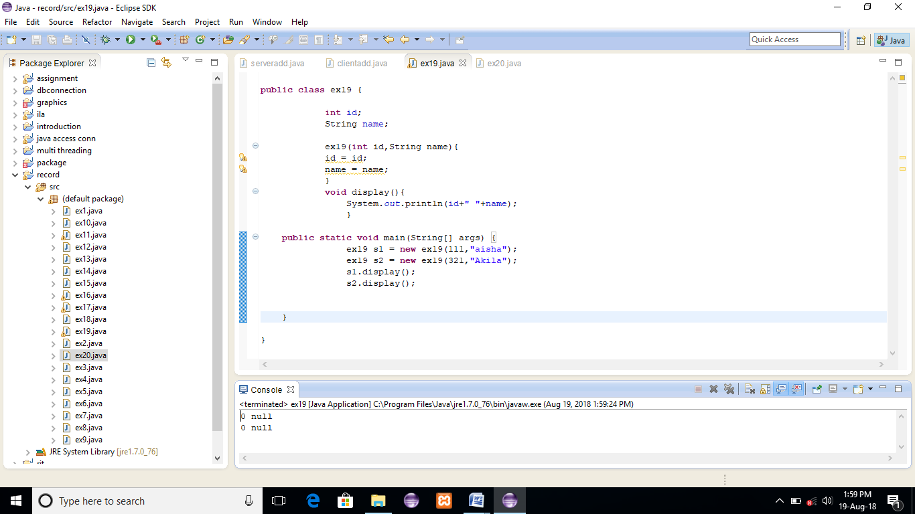

**RESULT:**

**EXERCISE 20:**

**public** **class** ex20 {

**int** id;

String name;

ex20(**int** id,String name){

**this**.id = id;

**this**.name = name;

}

**void** display(){System.*out*.println(id+" "+name);}

**public** **static** **void** main(String[] args) {

ex20 s1 = **new** ex20(111,"ilakiya");

ex20 s2 = **new** ex20(222,"Abinaya");

s1.display();

s2.display();

}

}

**OUTPUT:**

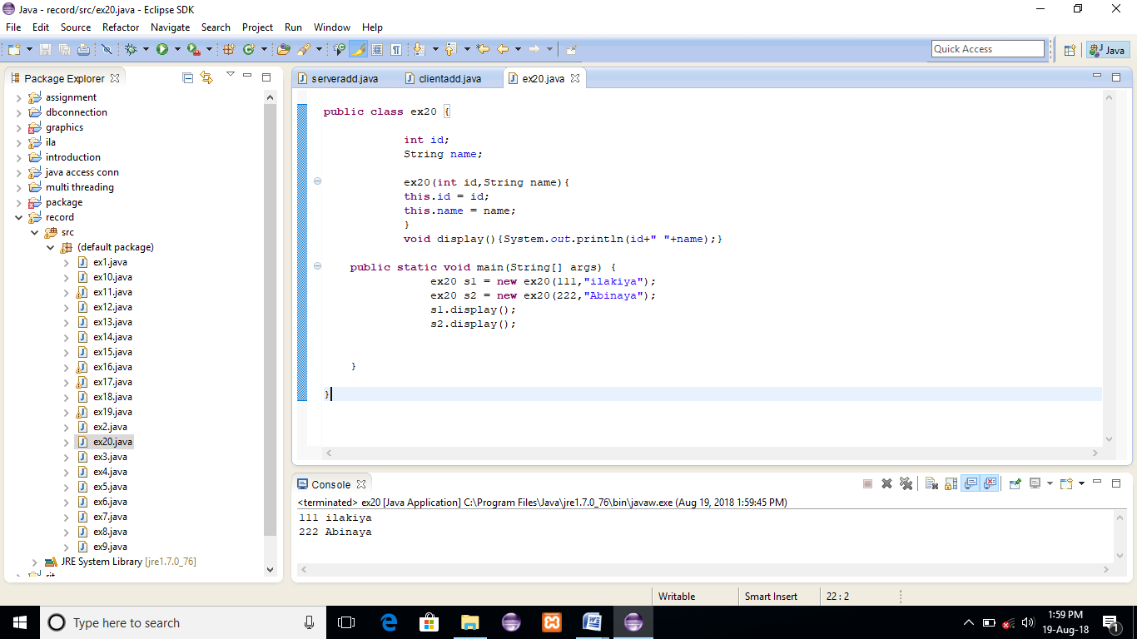

**RESULT:**

**EXERCISE 21:**

**public** **class** ex21 {

**int** id;

String name;

ex21(){System.*out*.println("default constructor is invoked");}

ex21(**int** id,String name){

**this** ();//it is used to invoked current class constructor.

**this**.id = id;

**this**.name = name;

}

**void** display(){System.*out*.println(id+" "+name);}

**public** **static** **void** main(String[] args) {

ex21 e1 = **new** ex21(111,"dharshini");

ex21 e2 = **new** ex21(222,"ilakiya");

e1.display();

e2.display();

}

}

**OUTPUT:**

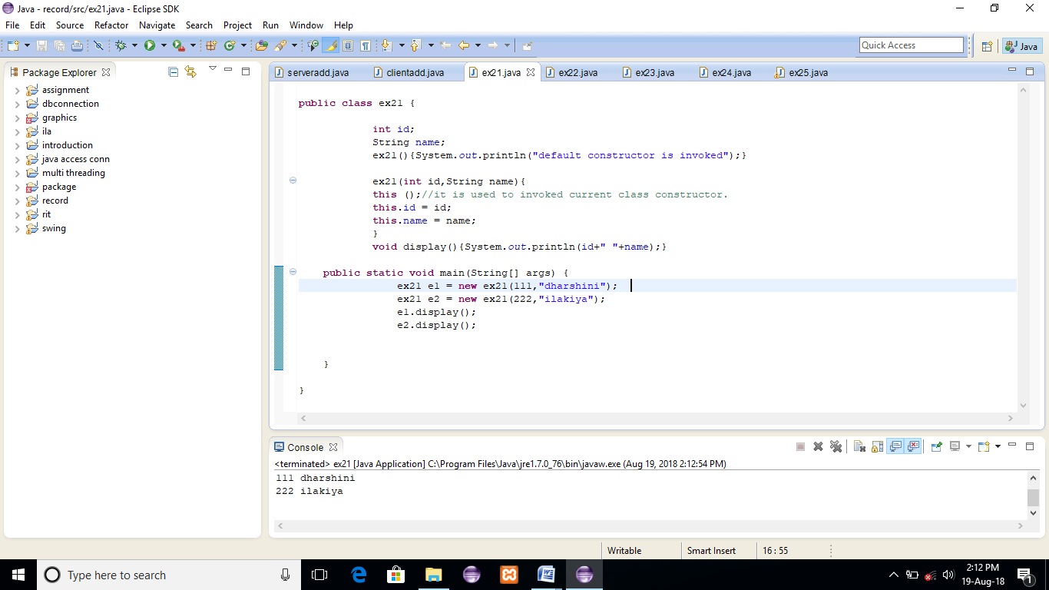

**RESULT:**

**EXERCISE 22:**

**public** **class** ex22 {

**int** id;

String name;

String city;

ex22(**int** id,String name){

**this**.id = id;

**this**.name = name;

}

ex22(**int** id,String name,String city){

**this**(id,name);//now no need to initialize id and name

**this**.city=city;

}

**void** display(){System.*out*.println(id+" "+name+" "+city);}

**public** **static** **void** main(String[] args) {

ex22 e1 = **new** ex22(111,"raj");

ex22 e2 = **new** ex22(222,"banu","delhi");

e1.display();

e2.display();

}

}

**OUTPUT:**

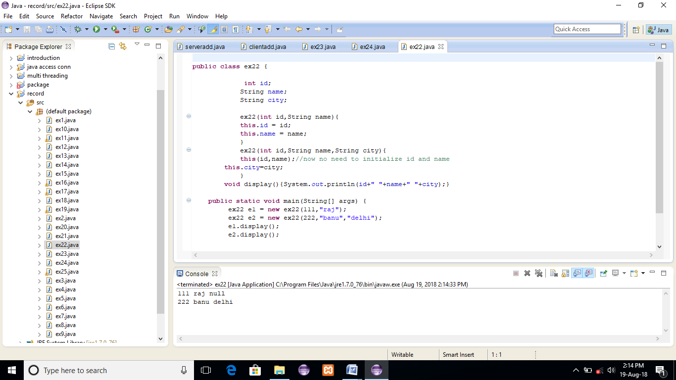

**RESULT:**

**EXERCISE 23:**

**public** **class** ex23 {

**void** m(){

System.*out*.println("method is invoked");

}

**void** n(){

**this**.m();//no need because compiler does it for you.

}

**void** p(){

n();//complier will add this to invoke n() method as this.n()

}

**public** **static** **void** main(String[] args) {

ex23 s1 = **new** ex23();

s1.p();

}

}

**OUTPUT:**

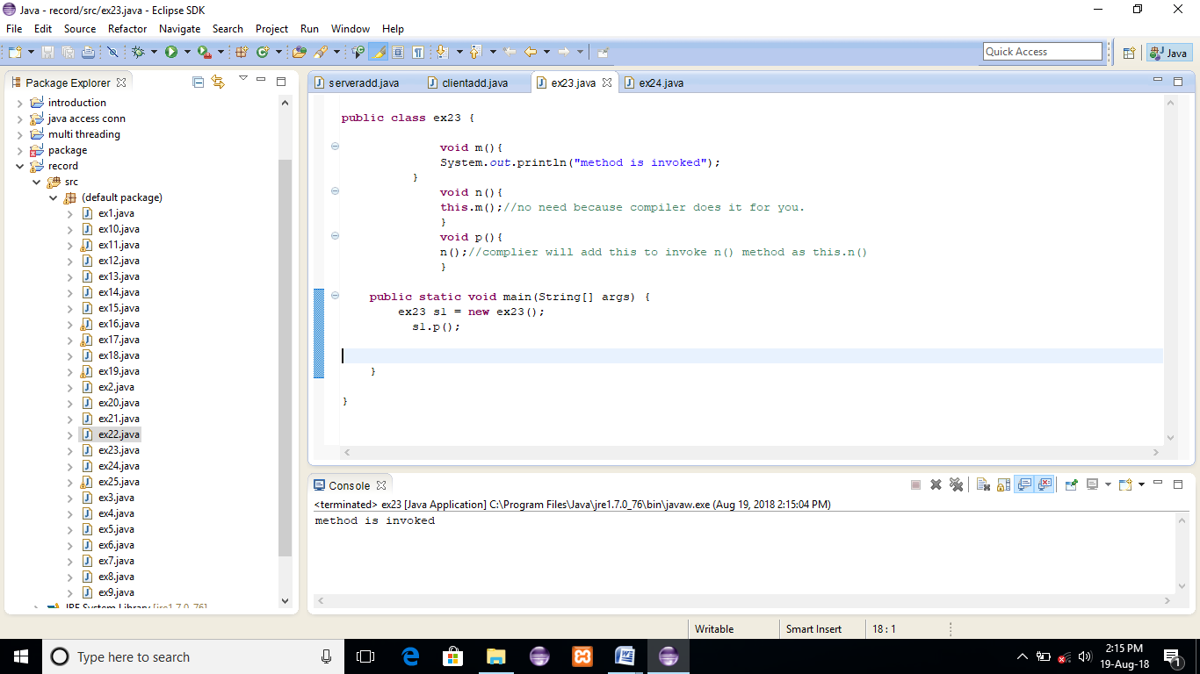

**RESULT:**

**EXERCISE 24:**

**public** **class** ex24 {

**void** m(ex24 obj){

System.*out*.println("method is invoked");

}

**void** p(){

m(**this**);

}

**public** **static** **void** main(String[] args) {

// **TODO** Auto-generated method stub

ex24 s1 = **new** ex24();

s1.p();

}

}

**OUTPUT:**

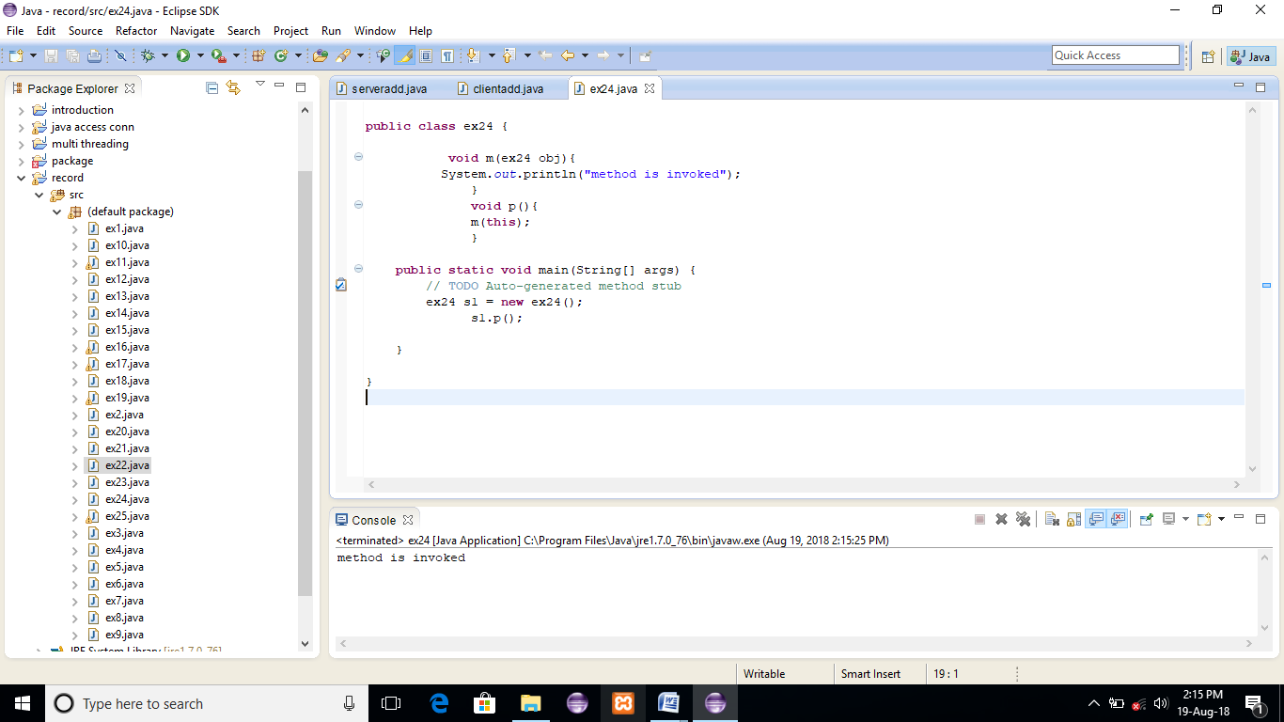

**RESULT:**

**EXERCISE 25:**

**public** **class** ex25 {

A4 obj;

ex25(A4 obj){

**this**.obj=obj;

}

**void** display(){

System.*out*.println(obj.data);//using data member of A4 class

}

}

**class** A4{

**int** data=10;

A4(){

ex25 b=**new** ex25(**this**);

b.display();

}

**public** **static** **void** main(String[] args) {

A4 a=**new** A4();

}

}

**OUTPUT:**

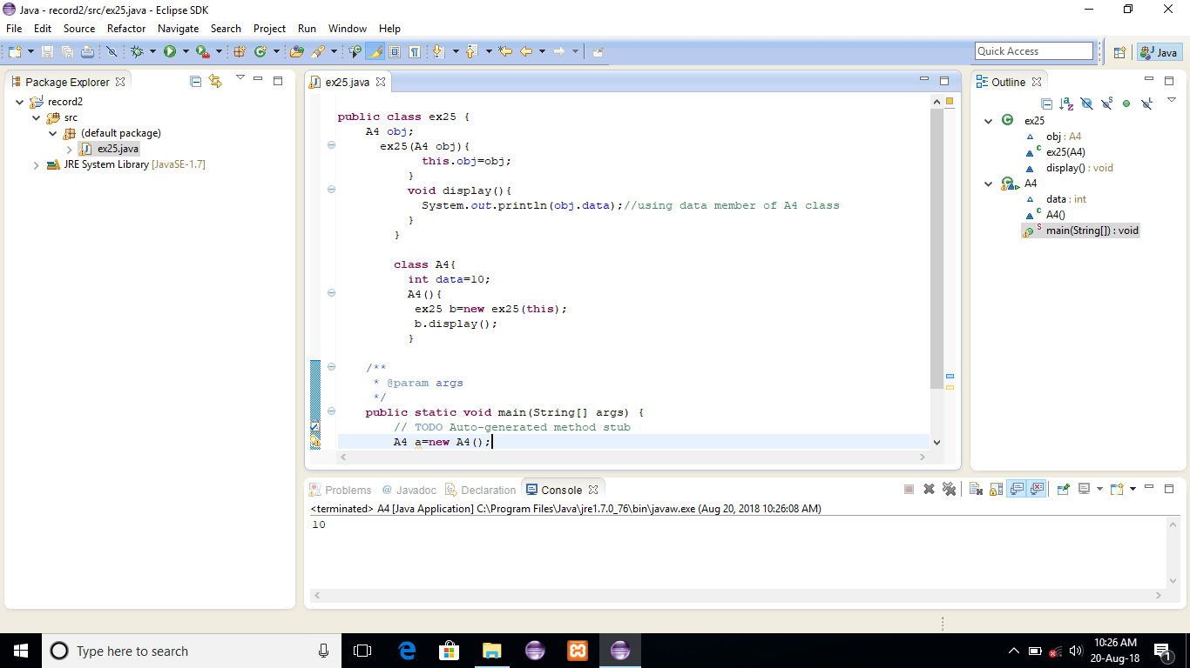

**RESULT:**

**EXERCISE 26:**

**public** **class** ex26 {

ex26 getA(){

**return** **this**;

}

**void** msg(){System.*out*.println("Hello java");}

}

**class** Test1{

**public** **static** **void** main(String[] args) {

**new** ex26().getA().msg();

}

}

**OUTPUT:**

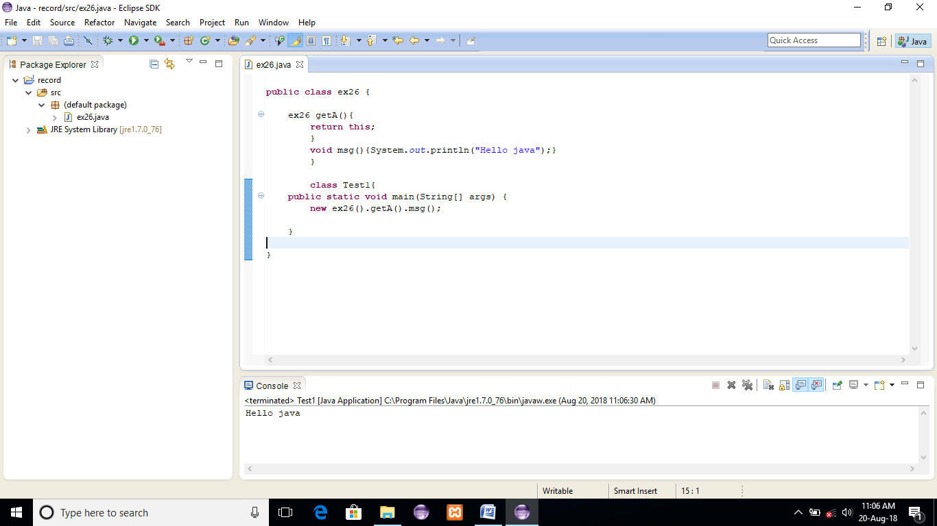

**RESULT:**

**EXERCISE 27:**

**public** **class** ex27 {

**float** salary=40000;

}

**class** Programmer **extends** ex27{

**int** bonus=10000;

**public** **static** **void** main(String[] args) {

Programmer p=**new** Programmer();

System.*out*.println("Programmer salary is:"+p.salary);

System.*out*.println("Bonus of Programmer is:"+p.bonus);

}

}

**OUTPUT:**

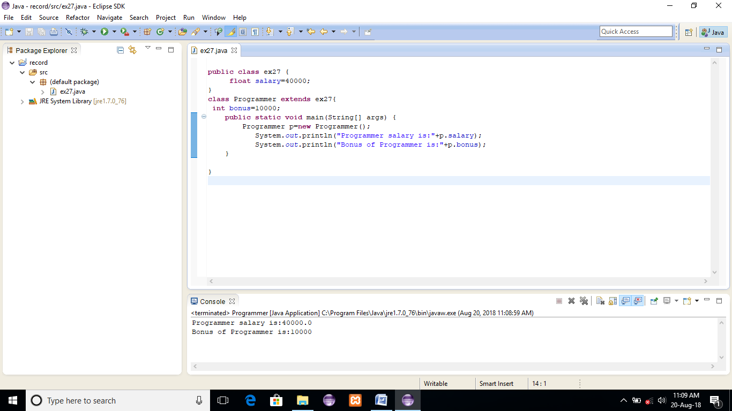

**RESULT:**

**EXERCISE 28:**

**public** **class** ex28 {

**void** msg(){System.*out*.println("Hello");}

}

**class** B{

**void** msg(){System.*out*.println("Welcome");}

}

**class** C **extends** ex28,B{

**public** **static** **void** main(String args[])

{

C obj=**new** C();

obj.msg();//Now which msg() method would be invoked?

}

}

**OUTPUT:**

Hello Welcome

**RESULT:**

**EXERCISE 29:**

**public** **class** ex29 {

**int** square(**int** n){

**return** n*n;

}

}

**class** Circle{

ex29 op;//aggregation

**double** pi=3.14;

**double** area(**int** radius){

op=**new** ex29();

**int** rsquare=op.square(radius);

**return** pi*rsquare;

}

**public** **static** **void** main(String[] args) {

Circle c=**new** Circle();

**double** result=c.area(5);

System.*out*.println(result);

}

}

**OUTPUT:**

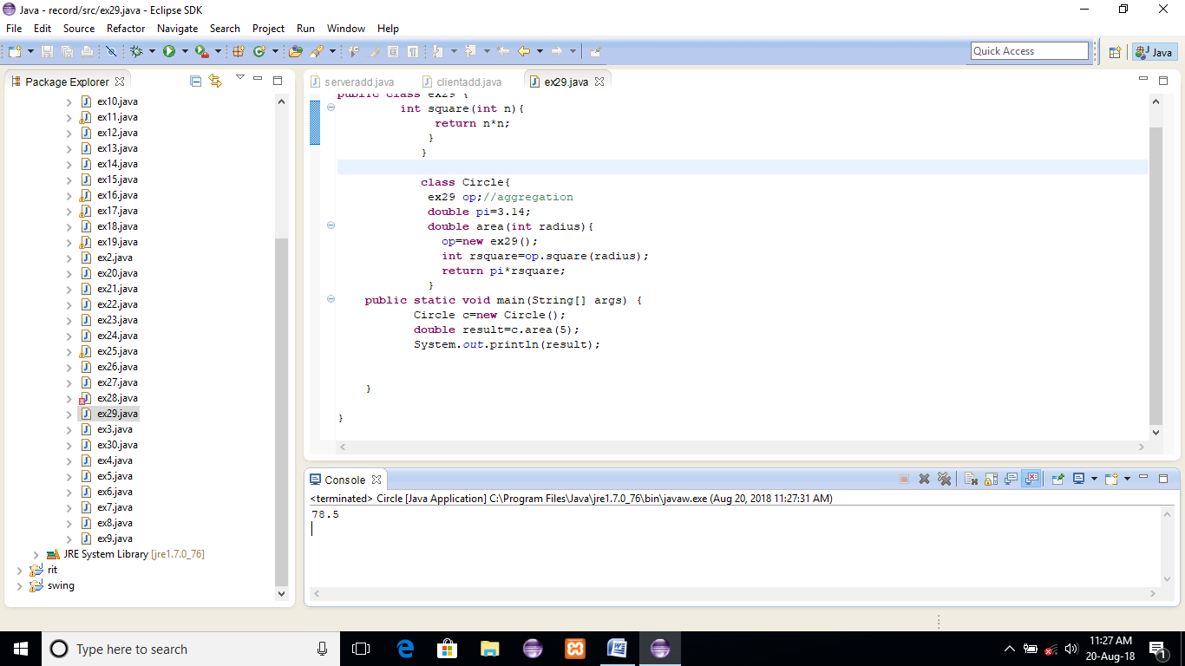

**RESULT:**

**EXERCISE 30:**

**public** **class** ex30 {

**void** run(){System.*out*.println("Vehicle is running");}

}

**class** Bike **extends** ex30{

**public** **static** **void** main(String[] args) {

Bike obj = **new** Bike();

obj.run();

}

}

**OUTPUT:**

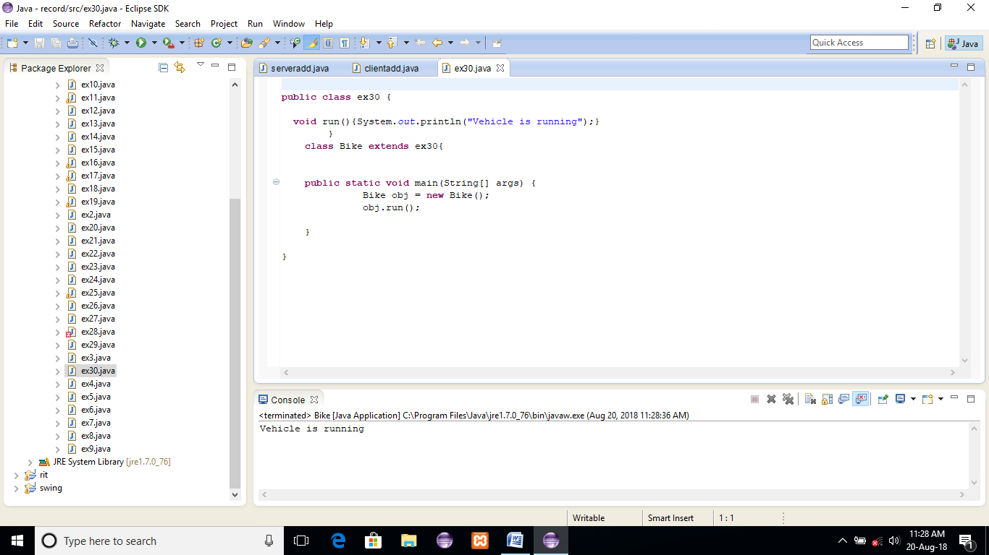

**RESULT:**

**EXERCISE 31:**

**public** **class** ex31 {

**void** run(){System.*out*.println("Vehicle is running");}

}

**class** Bike2 **extends** ex31{

**void** run(){System.*out*.println("Bike is running safely");}

**public** **static** **void** main(String[] args) {

Bike2 obj = **new** Bike2();

obj.run();

}

}

**OUTPUT:**

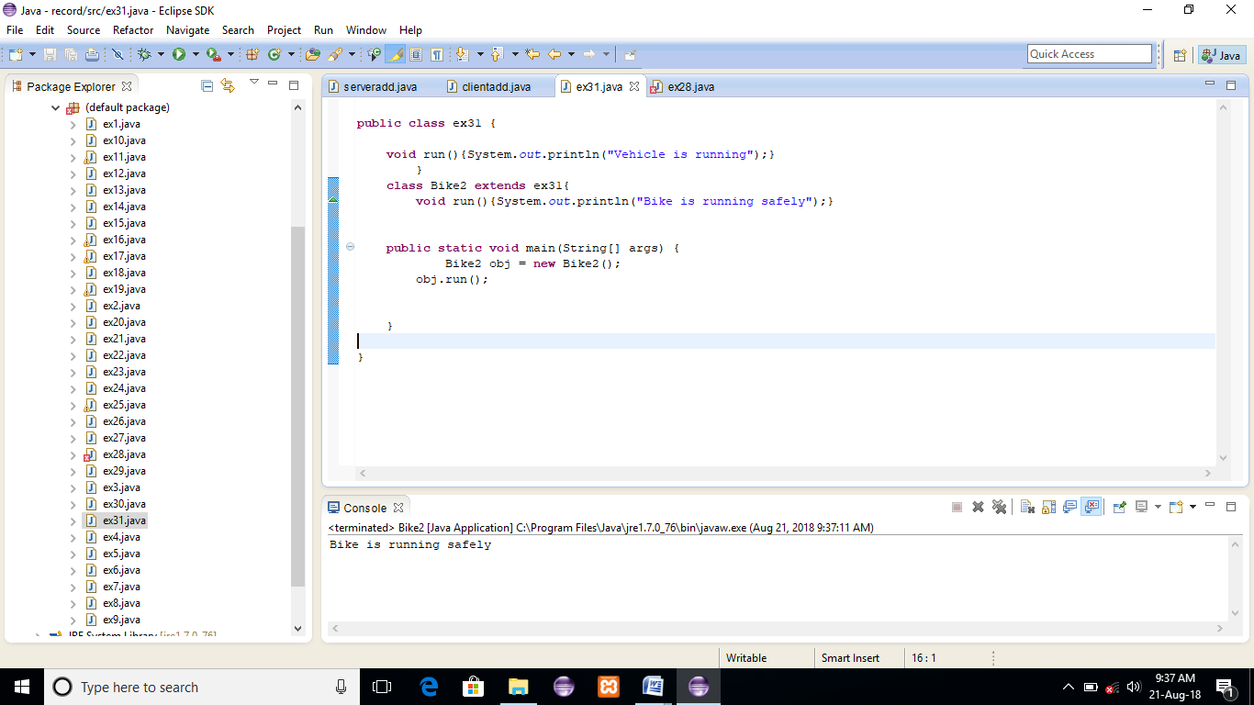

**RESULT:**

**EXERCISE 32:**

**public** **class** ex32 {

**int** speed=50;

}

**class** Bike3 **extends** ex32{

**int** speed=100;

**void** display(){

System.*out*.println(speed);//will print speed of Bike

}

**public** **static** **void** main(String[] args) {

// **TODO** Auto-generated method stub

Bike3 b=**new** Bike3();

b.display();

}

}

**OUTPUT:**

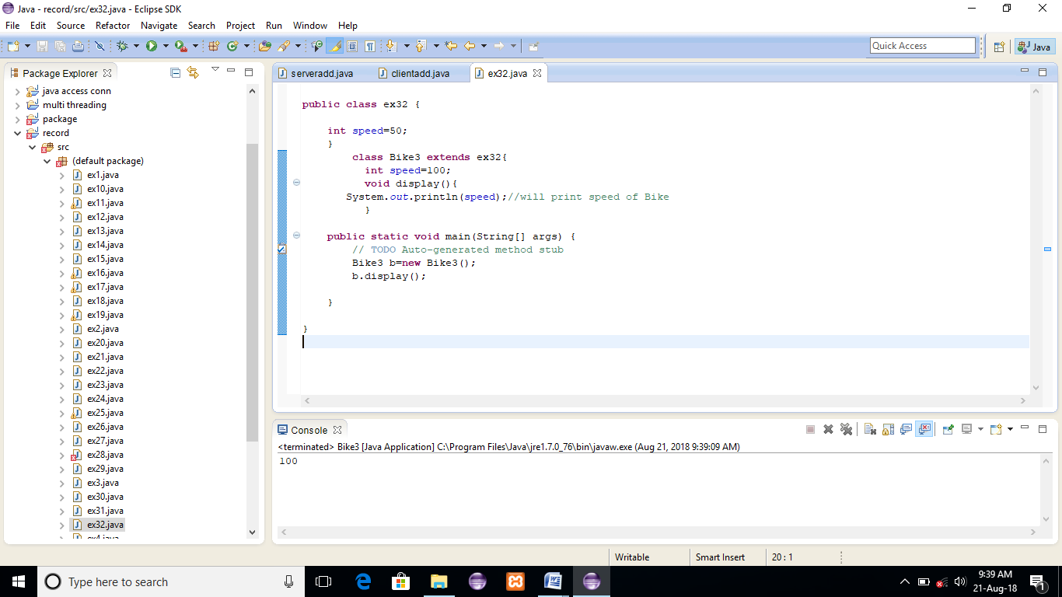

**RESULT:**

**EXERCISE 33:**

**public** **class** ex33 {

**int** speed=50;

}

**class** Bike4 **extends** ex33{

**int** speed=100;

**void** display(){

System.*out*.println(**super**.speed);//will print speed of Vehicle now

}

**public** **static** **void** main(String[] args) {

Bike4 b=**new** Bike4();

b.display();

}

}

**OUTPUT:**

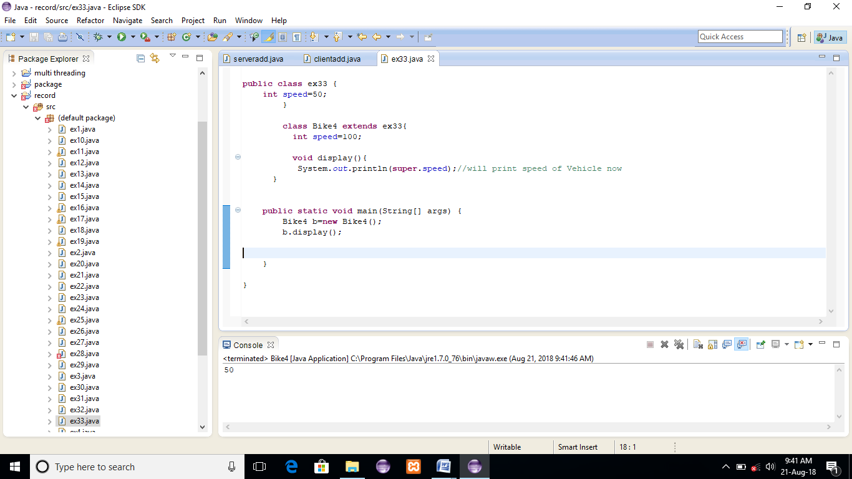

**RESULT:**

**EXERCISE 34:**

**public** **class** ex34 {

ex34(){System.*out*.println("Vehicle is created");}

}

**class** Bike5 **extends** ex34{

Bike5(){

**super**();//will invoke parent class constructor

System.*out*.println("Bike is created");

}

**public** **static** **void** main(String[] args) {

Bike5 b=**new** Bike5();

}

}

**OUTPUT:**

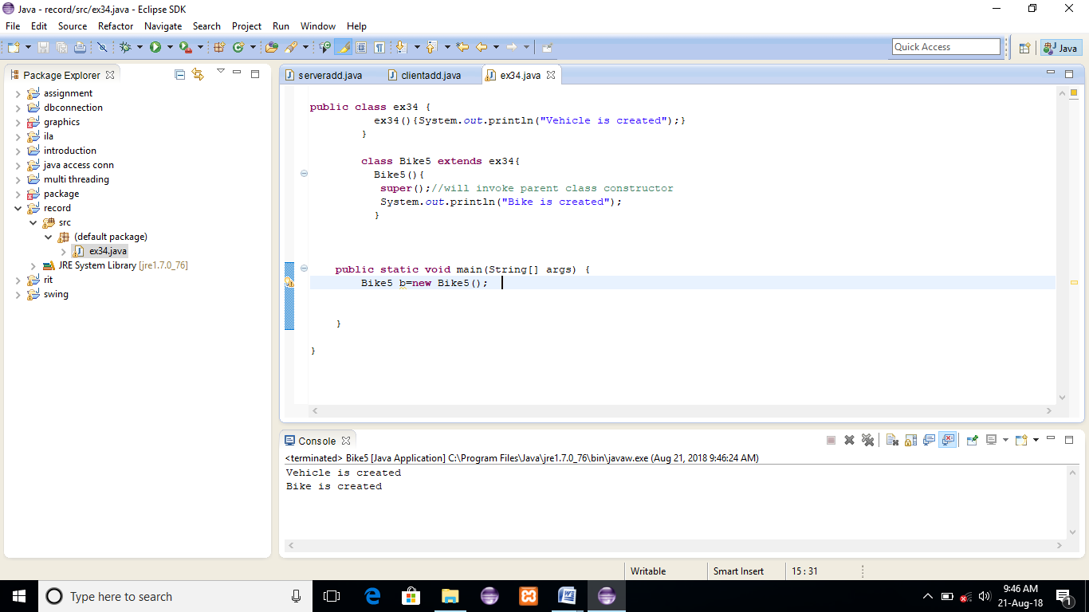

**RESULT:**

**EXERCISE 35:**

**public** **class** ex35 {

**void** message(){System.*out*.println("welcome");}

}

**class** Student16 **extends** ex35{

**void** message(){System.*out*.println("welcome to java");}

**void** display(){

message();//will invoke current class message() method

**super**.message();//will invoke parent class message() method

}

**public** **static** **void** main(String[] args) {

Student16 s=**new** Student16();

s.display();

}

}

**OUTPUT:**

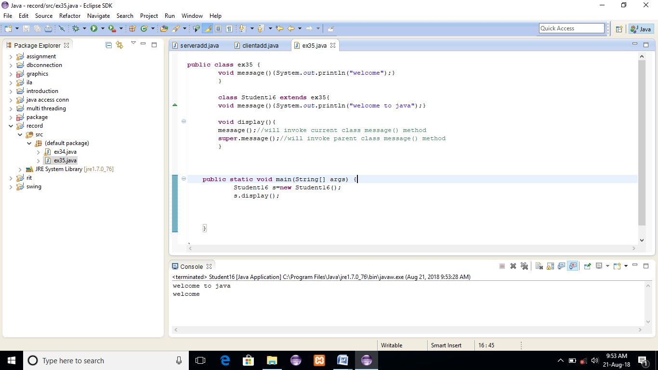

**RESULT:**

**EXERCISE 36:**

**public** **class** ex36 {

**final** **int** speedlimit=90;//final variable

**void** run(){

**int** speedlimit=400;

}

**public** **static** **void** main(String[] args) {

ex36 obj=**new** ex36();

obj.run();

}

}

**OUTPUT:**

90

**RESULT:**

**EXERCISE 37:**

**public** **class** ex37 {

**final** **void** run()

{

System.*out*.println("running");

}

}

**class** Honda **extends** ex37{

**void** run()

{

System.*out*.println("running safely with 100kmph");

}

**public** **static** **void** main(String[] args) {

// **TODO** Auto-generated method stub

Honda honda= **new** Honda();

honda.run();

}

}

**OUTPUT:**

Running

**RESULT:**

**EXERCISE 38:**

**import** java.lang.*;

**import** java.util.*;

**import** java.io.*;

**final** **class** Bike{}

**class** Honda1 **extends** Honda {

**void** honda()

{

System.*out*.println("running safely with 100kmph");

}

**public** **static** **void** main(String args[]){

Honda1 honda= **new** Honda1();

honda.run();

}

}

**OUTPUT:**

Running safely with 100kmph

**RESULT:**

**EXERCISE 39:**

**public** **class** ex39 {

**final** **void** run(){System.*out*.println("running...");}

}

**class** Honda2 **extends** ex39{

**public** **static** **void** main(String[] args) {

**new** Honda2().run();

}

}

**OUTPUT:**

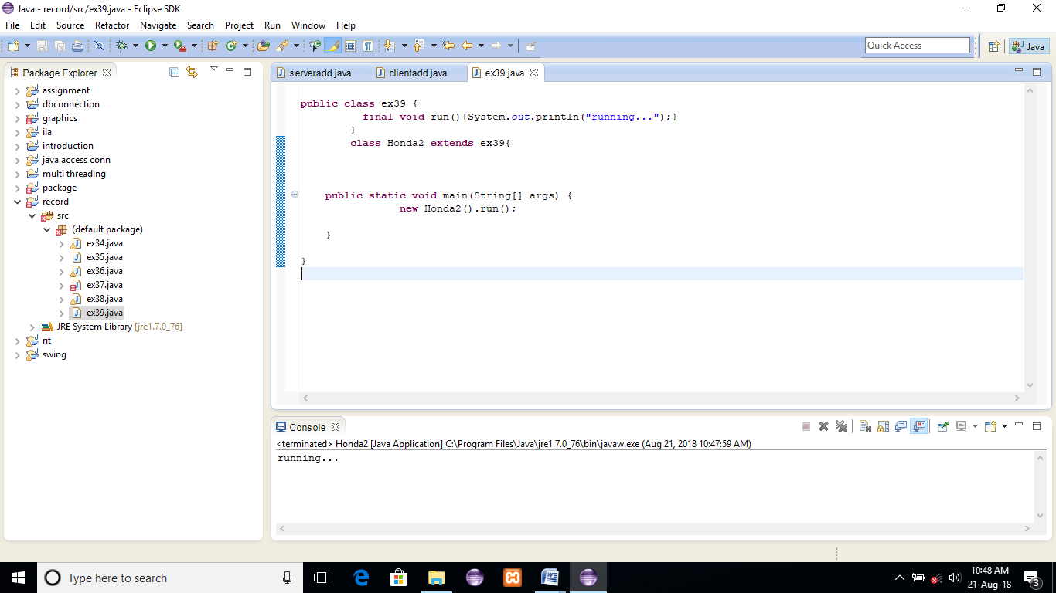

**RESULT:**

**EXERCISE 40:**

**public** **class** ex40 {

**int** getRateOfInterest(){**return** 0;}

}

**class** SBI **extends** ex40{

**int** getRateOfInterest(){**return** 8;}

}

**class** ICICI **extends** ex40{

**int** getRateOfInterest(){**return** 7;}

}

**class** AXIS **extends** ex40{

**int** getRateOfInterest(){**return** 9;}

}

**class** Test3

**public** **static** **void** main(String[] args) {

ex40 b1=**new** SBI();

ex40 b2=**new** ICICI();

ex40 b3=**new** AXIS();

System.*out*.println("SBI Rate of Interest: "+b1.getRateOfInterest());

System.*out*.println("ICICI Rate of Interest: "+b2.getRateOfInterest());

System.*out*.println("AXIS Rate of Interest: "+b3.getRateOfInterest());

}

}

**OUTPUT:**

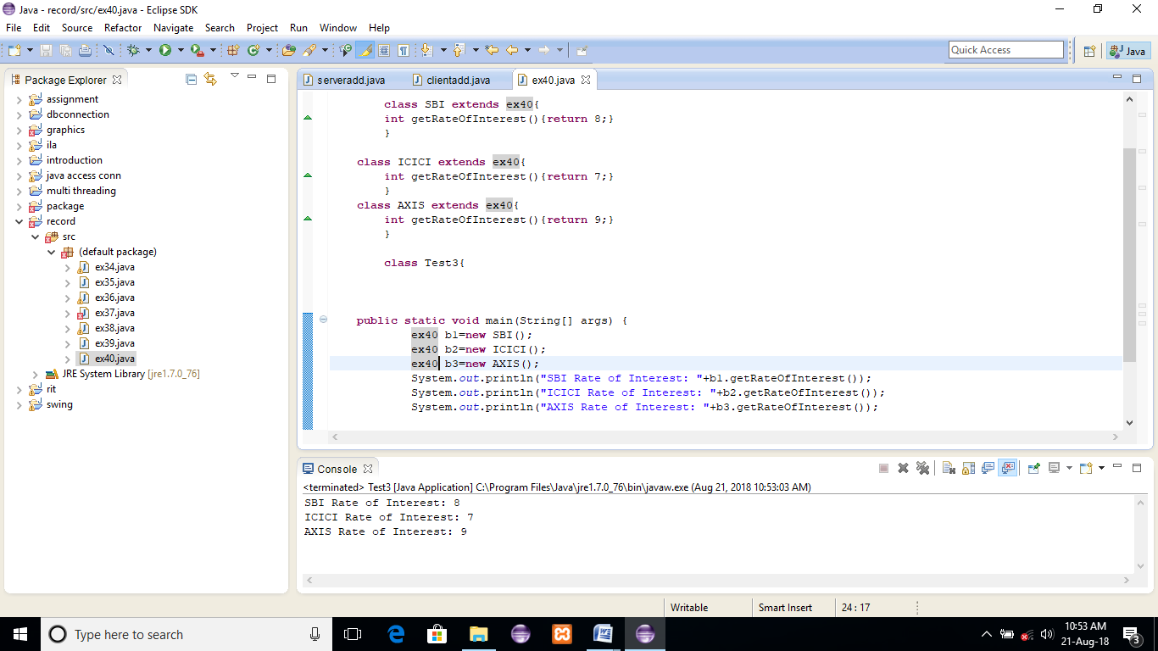

**RESULT:**

**EXERCISE 41:**

**public** **class** ex41 {

**void** eat(){System.*out*.println("eating");}

}

**class** Dog **extends** ex41{

**void** eat(){System.*out*.println("eating fruits");}

}

**class** BabyDog **extends** Dog{

**void** eat(){System.*out*.println("drinking milk");}

**public** **static** **void** main(String[] args) {

ex41 a1,a2,a3;

a1=**new** ex41();

a2=**new** Dog();

a3=**new** BabyDog();

a1.eat();

a2.eat();

a3.eat();

}

}

**OUTPUT:**

eating

eating fruits

drinking Milk

**RESULT:**

**EXERCISE 42:**

**public** **class** ex42 {

**private** **void** eat(){

System.*out*.println("dog is eating...");

}

**public** **static** **void** main(String[] args) {

ex42 d1=**new** ex42();

d1.eat();

}

}

**OUTPUT:**

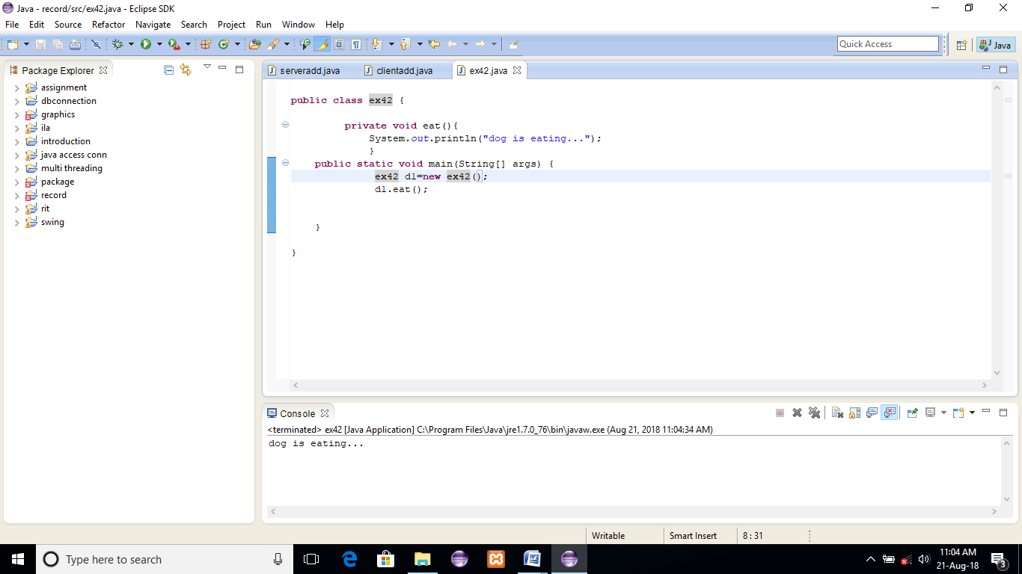

**RESULT:**

**EXERCISE 43:**

**public** **class** ex43 {

**void** eat(){System.*out*.println("animal is eating...");}

}

**class** Dog1 **extends** ex43{

**void** eat(){System.*out*.println("dog is eating...");}

**public** **static** **void** main(String args[]){

ex43 a=**new** Dog1();

a.eat();

}

}

**OUTPUT:**

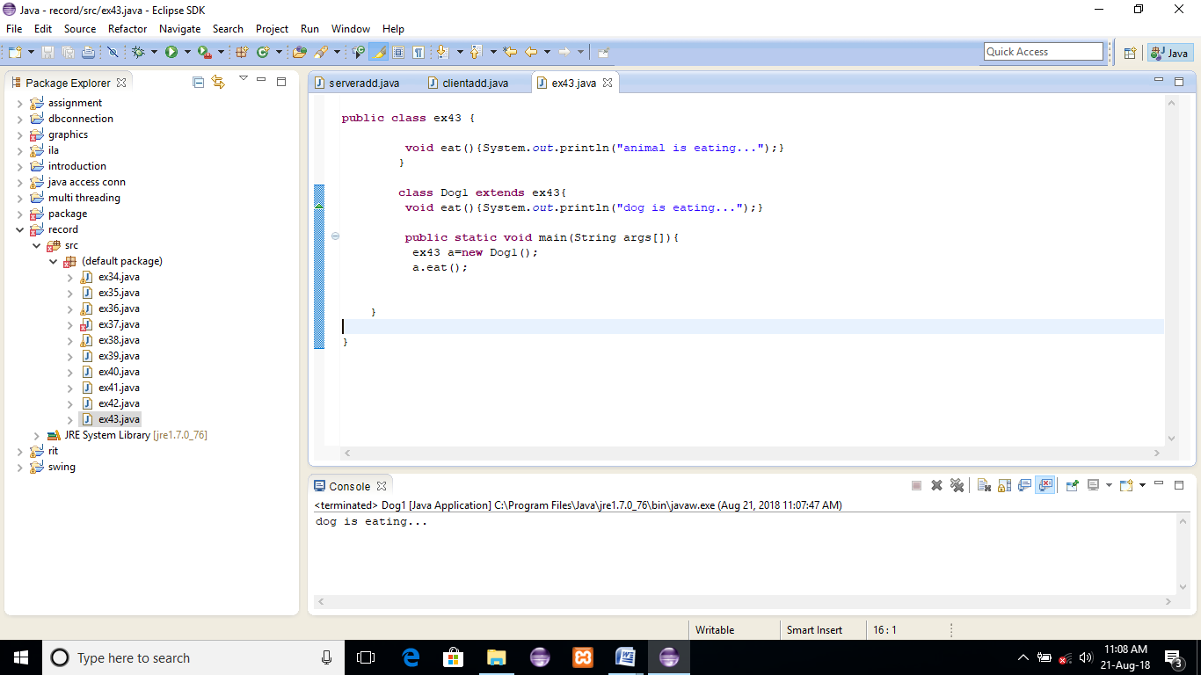

**RESULT:**

**EXERCISE 45:**

**public** **class** ex45 {

**public** **static** **void** main(String[] args) {

ex45 s=**new** ex45();

System.*out*.println(s **instanceof** ex45);//true

}

}

**OUTPUT:**

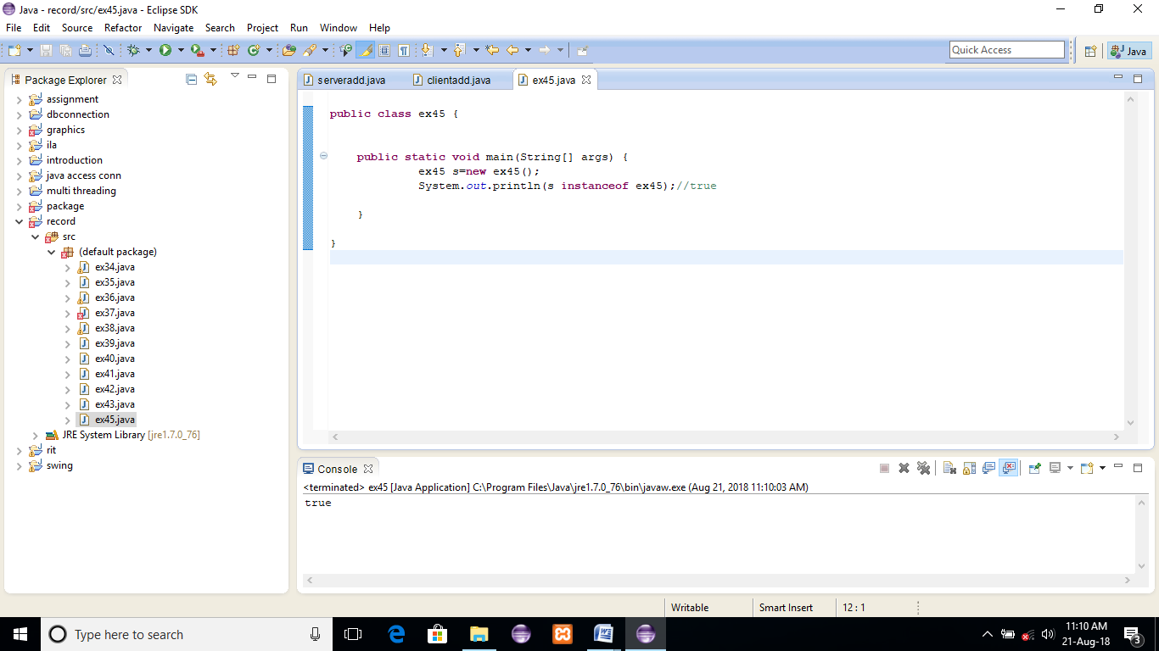

**RESULT:**

**EXERCISE 44:**

**public** **class** ex44 {

**static** **class** Dog2 **extends** ex44{//Dog inherits Animal

**public** **static** **void** main(String[] args) {

Dog2 d=**new** Dog2();

System.*out*.println(d **instanceof** ex44);//true

}

}

}

**OUTPUT:**

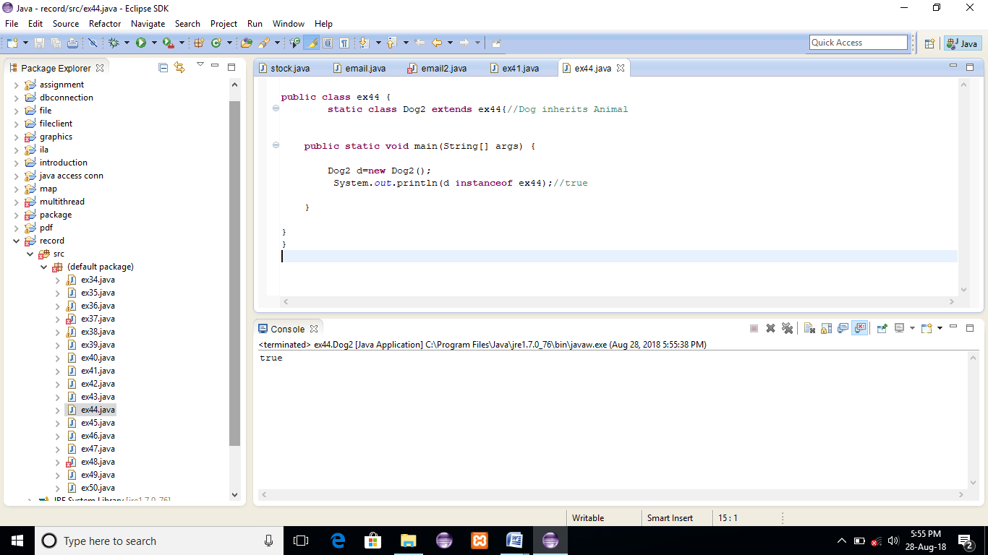

**RESULT:**

**EXERCISE 46:**

**abstract** **class** ex46 {

**abstract** **void** run();

}

**class** Honda4 **extends** ex46{

**void** run(){System.*out*.println("running safely..");}

**public** **static** **void** main(String[] args) {

// **TODO** Auto-generated method stub

Honda4 obj = **new** Honda4();

obj.run();

}

}

**OUTPUT:**

Running safely..

**RESULT:**

**EXERCISE 47:**

**abstract** **class** Bike1{

Bike1(){System.*out*.println("bike is created");}

**abstract** **void** run();

**void** changeGear(){System.*out*.println("gear changed");}

}

**class** Honda3 **extends** Bike1{

**void** run(){System.*out*.println("running safely..");}

}

**class** TestAbstraction2{

**public** **static** **void** main(String args[]){

Bike1 obj = **new** Honda3();

obj.run();

obj.changeGear();

}

}

**OUTPUT:**

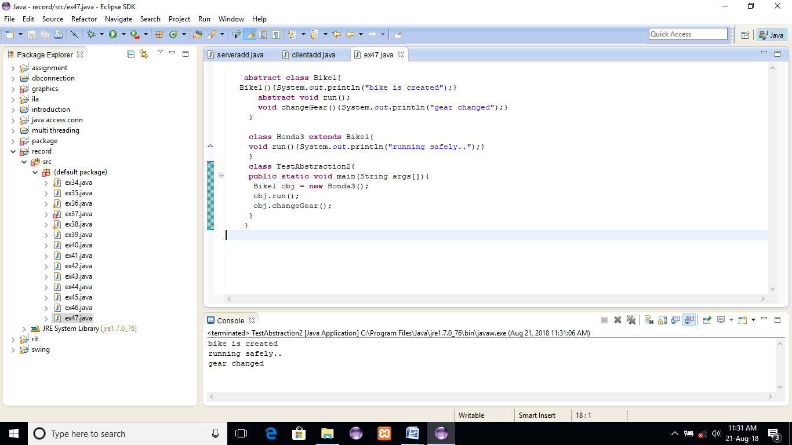

**RESULT:**

**EXERCISE 48:**

**interface** printable{

**void** print();

}

**class** A6 **implements** printable{

**public** **void** print(){System.*out*.println("Hello");}

**public** **static** **void** main(String args[]){

A6 obj = **new** A6();

obj.print();

}

}

**OUTPUT:**

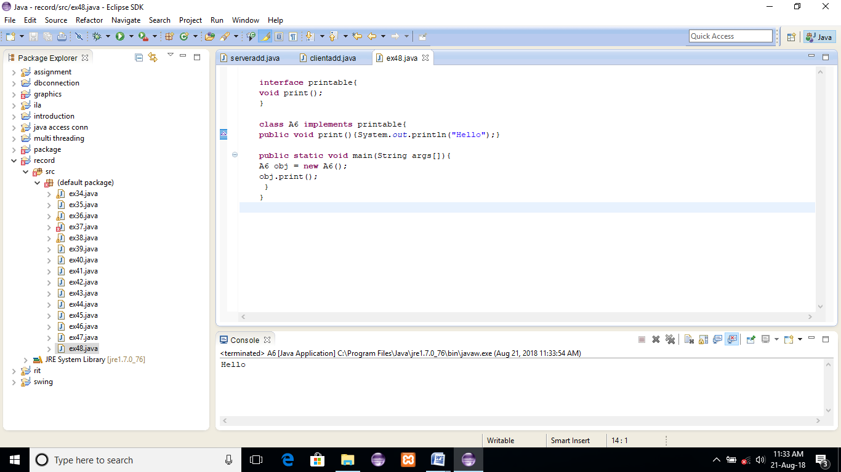

**RESULT:**

**EXERCISE 49:**

**interface** Printable{

**void** print();

}

**interface** Showable{

**void** print();

}

**class** TestTnterface1 **implements** Printable,Showable{

**public** **void** print(){System.*out*.println("Hello");}

**public** **static** **void** main(String args[]){

TestTnterface1 obj = **new** TestTnterface1();

obj.print();

}

}

**OUTPUT:**

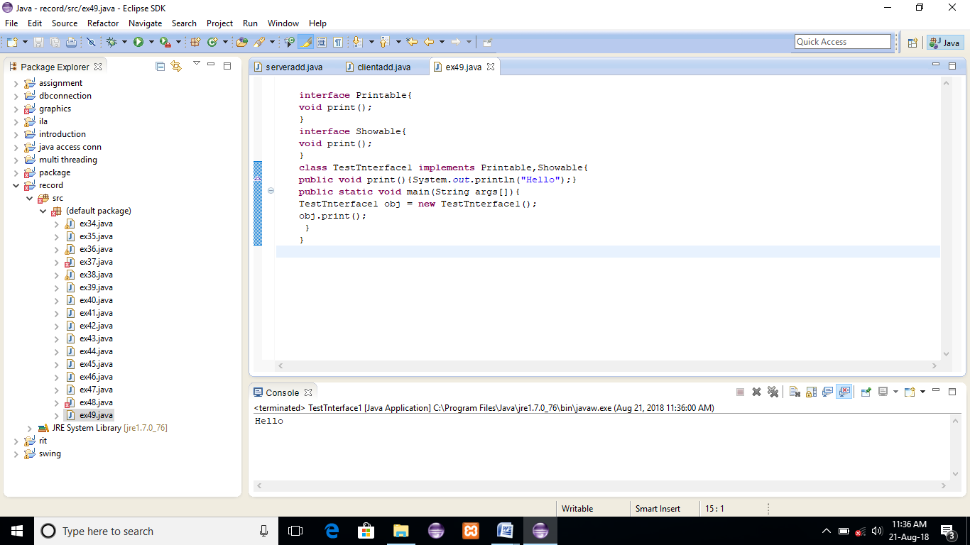

**RESULT:**

**EXERCISE 50:**

//Creating interface that has 4 methods

**interface** A{

**void** a();//bydefault, public and abstract

**void** b();

**void** c();

**void** d();

}

//Creating abstract class that provides the implementation of one method of A interface

**abstract** **class** B **implements** A{

**public** **void** c(){System.*out*.println("I am C");}

}

//Creating subclass of abstract class, now we need to provide the implementation of rest of the methods

**class** M **extends** B{

**public** **void** a(){System.*out*.println("I am a");}

**public** **void** b(){System.*out*.println("I am b");}

**public** **void** d(){System.*out*.println("I am d");}

}

//Creating a test class that calls the methods of A interface

**class** Test5{

**public** **static** **void** main(String args[]){

A a=**new** M();

a.a();

a.b();

a.c();

a.d();

}

}

**OUTPUT:**

I am a

I am b

I am c

I am d

**RESULT:**

**EXERCISE 51:**

**class** A{

**private** **int** data=40;

**private** **void** msg(){System.out.println("Hello java");}

}

**public** **class** Simple{

**public** **static** **void** main(String args[]){

   A obj=**new** A();

   System.out.println(obj.data);

   obj.msg();

   }

}

**OUTPUT:**

Compile Time Error

**RESULT:**

**EXERCISE 52:**

**package** pack;

**class** A{

**void** msg(){System.out.println("Hello");}

}

//save by B.java

**package** mypack;

**import** pack.*;

**class** B{

**public** **static** **void** main(String args[]){

   A obj = **new** A();

   obj.msg();

  }

}

**OUTPUT:**

Compile Time Error

**RESULT:**

**EXERCISE 53:**

**package** pack;

**public** **class** A{

**protected** **void** msg(){System.out.println("Hello");}

}

**package** mypack;

**import** pack.*;

**class** B **extends** A{

**public** **static** **void** main(String args[]){

   B obj = **new** B();

   obj.msg();

  }

}

**OUTPUT:**

Hello

**RESULT:**

**EXERCISE 54:**

**package** pack;

**public** **class** A{

**public** **void** msg(){System.out.println("Hello");}

}

**package** mypack;

**import** pack.*;

**class** B{

**public** **static** **void** main(String args[]){

   A obj = **new** A();

   obj.msg();

  }

}

**OUTPUT:**

Hello

**RESULT:**

**EXERCISE 55:**

**package** com.javatpoint;

**public** **class** Student{

**private** String name;

**public** String getName(){

**return** name;

}

**public** **void** setName(String name){

**this**.name=name

}

}

//save as Test.java

**package** com.javatpoint;

**class** Test{

**public** **static** **void** main(String[] args){

Student s=**new** Student();

s.setName("DHONI");

System.out.println(s.getName());

}

}

**OUTPUT:**

DHONI

**RESULT:**

**EXERCISE 56:**

**class** Student18 **implements** Cloneable{

**int** rollno;

String name;

Student18(**int** rollno,String name){

**this**.rollno=rollno;

**this**.name=name;

}

**public** Object clone()**throws** CloneNotSupportedException{

**return** **super**.clone();

}

**public** **static** **void** main(String args[]){

**try**{

Student18 s1=**new** Student18(101,"ILAKIYA");

Student18 s2=(Student18)s1.clone();

System.out.println(s1.rollno+" "+s1.name);

System.out.println(s2.rollno+" "+s2.name);

}**catch**(CloneNotSupportedException c){}

}

}

**OUTPUT:**

101 ILAKIYA

101 ILAKIYA

**RESULT:**

**EXERCISE 57:**

**class** Testarray{

**public** **static** **void** main(String args[]){

**int** a[]=**new** **int**[5];

a[0]=10;

a[1]=20;

a[2]=70;

a[3]=40;

a[4]=50;

**for**(**int** i=0;i<a.length;i++)

System.out.println(a[i]);

}}

**OUTPUT:**

10

20

70

40

50

**RESULT:**

**EXERCISE 58:**

**class** Testarray2{

**static** **void** min(**int** arr[]){

**int** min=arr[0];

**for**(**int** i=1;i<arr.length;i++)

**if**(min>arr[i])

  min=arr[i];

System.out.println(min);

}

**public** **static** **void** main(String args[]){

**int** a[]={33,3,4,5};

min(a);

}}

**OUTPUT:**

3

**RESULT:**

**EXERCISE 59:**

**class** Testarray3{

**public** **static** **void** main(String args[]){

**int** arr[][]={{1,2,3},{2,4,5},{4,4,5}};

**for**(**int** i=0;i<3;i++){

**for**(**int** j=0;j<3;j++){

   System.out.print(arr[i][j]+" ");

 }

 System.out.println();

}

}}

**OUTPUT:**

1 2 3

2 4 5

4 4 5

**RESULT:**

**EXERCISE 60:**

**class** TestArrayCopyDemo {

**public** **static** **void** main(String[] args) {

**char**[] copyFrom = { 'd', 'e', 'c', 'a', 'f', 'f', 'e',

                'i', 'n', 'a', 't', 'e', 'd' };

**char**[] copyTo = **new** **char**[7];

        System.arraycopy(copyFrom, 2, copyTo, 0, 7);

        System.out.println(**new** String(copyTo));

    }

}

**OUTPUT:**

Caffein

**RESULT:**

**EXERCISE 61:**

**class** matadd{

**public** **static** **void** main(String args[]){

**int** a[][]={{1,3,4},{3,4,5}};

**int** b[][]={{1,3,4},{3,4,5}};

**int** c[][]=**new** **int**[2][3];

**for**(**int** i=0;i<2;i++){

**for**(**int** j=0;j<3;j++){

c[i][j]=a[i][j]+b[i][j];

System.out.print(c[i][j]+" ");

}

System.out.println();

}

}}

**OUTPUT:**

2 6 8

6 8 10

**RESULT:**

**EXERCISE 62:**

**public** **class** WrapperExample1{

**public** **static** **void** main(String args[]){

**int** a=20;

Integer i=Integer.valueOf(a);

Integer j=a;

System.out.println(a+" "+i+" "+j);

}}

**OUTPUT:**

20 20 20

**RESULT:**

**EXERCISE 63:**

**public** **class** WrapperExample2{

**public** **static** **void** main(String args[]){

Integer a=**new** Integer(3);

**int** i=a.intValue();

**int** j=a;

System.out.println(a+" "+i+" "+j);

}}

**OUTPUT:**

3 3 3

**RESULT:**

**EXERCISE 64:**

**class** Operation{

**int** data=50;

**void** change(**int** data){

 data=data+100;//changes will be in the local variable only

 }

**public** **static** **void** main(String args[]){

   Operation op=**new** Operation();

   System.out.println("before change "+op.data);

   op.change(500);

   System.out.println("after change "+op.data);

 }

}

OUTPUT:

before change 50

after change 50

**RESULT:**

**EXERCISE 65:**

**class** A{

**public** **static** **void** main(String args[]){

**for**(**int** i=0;i<args.length;i++)

System.out.println(args[i]);

}

}

compile by > javac A.java

run by > java A sonoo jaiswal 1 3 abc

**OUTPUT:**

sonoo

jaiswal

1

3

abc

**RESULT:**

**EXERCISE 66:**

**public** **class** StringExample{

**public** **static** **void** main(String args[]){

String s1="java";//creating string by java string literal

**char** ch[]={'s','t','r','i','n','g','s'};

String s2=**new** String(ch);//converting char array to string

String s3=**new** String("example");//creating java string by new keyword

System.out.println(s1);

System.out.println(s2);

System.out.println(s3);

}}

**OUTPUT:**

java

strings

example

**RESULT:**

**EXERCISE 67:**

**class** Testimmutablestring{

**public** **static** **void** main(String args[]){

   String s="Sachin";

   s.concat(" Tendulkar");//concat() method appends the string at the end

   System.out.println(s);//will print Sachin because strings are immutable objects

 }

}

**OUTPUT:**

Sachin

**RESULT:**

**EXERCISE 68:**

**class** Teststringcomparison1{

**public** **static** **void** main(String args[]){

   String s1="Sachin";

   String s2="Sachin";

   String s3=**new** String("Sachin");

   String s4="Saurav";

   System.out.println(s1.equals(s2));//true

   System.out.println(s1.equals(s3));//true

   System.out.println(s1.equals(s4));//false

 }

}

**OUTPUT:**

true

true

false

**RESULT:**

**EXERCISE 69:**

**class** Teststringcomparison3{

**public** **static** **void** main(String args[]){

   String s1="Sachin";

   String s2="Sachin";

   String s3=**new** String("Sachin");

   System.out.println(s1==s2);//true (because both refer to same instance)

   System.out.println(s1==s3);//false(because s3 refers to instance created in nonpool)

 }

}

**OUTPUT:**

true

false

**RESULT:**

**EXERCISE 70:**

**class** Teststringcomparison4{

**public** **static** **void** main(String args[]){

   String s1="Sachin";

   String s2="Sachin";

   String s3="Ratan";

   System.out.println(s1.compareTo(s2));//0

   System.out.println(s1.compareTo(s3));//1(because s1>s3)

   System.out.println(s3.compareTo(s1));//-1(because s3 < s1 )

 }

}

**OUTPUT:**

0

1

-1

**RESULT:**

**EXERCISE 71:**

**class** TestStringConcatenation1{

**public** **static** **void** main(String args[]){

   String s="ILAKIYA"+"SREE";

   System.out.println(s);

 }

}

**OUTPUT:**

ILAKIYA SREE

**RESULT:**

**EXERCISE 72:**

**class** TestStringConcatenation2{

**public** **static** **void** main(String args[]){

   String s=50+30+"Dhoni"+40+40;

   System.out.println(s);

 }

}

**OUTPUT:**

80Dhoni4040

**RESULT:**

**EXERCISE 73:**

**public** **class** TestSubstring{

**public** **static** **void** main(String args[]){

   String s="SachinTendulkar";

   System.out.println(s.substring(6));

   System.out.println(s.substring(0,6));

 }

}

**OUTPUT:**

Tendulkar

Sachin

**RESULT:**

**EXERCISE 74:**

**public** **class** str{

**public** **static** **void** main(String args[]){

String s1="hello string";

String s2="JAVATPOINT”;

String s1upper=s1.toUpperCase();

String s2lower=s1.toLowerCase();

System.out.println(s1upper);

 System.out.println(s2lower);

}}

**OUTPUT:**

HELLO STRING

javatpoint

**RESULT:**

**EXERCISE 75:**

**public** **class** StringTrimExample{

**public** **static** **void** main(String args[]){

String s1="  hello string   ";

System.out.println(s1+"javatpoint");//without trim()

System.out.println(s1.trim()+"javatpoint");//with trim()

}}

**OUTPUT:**

hello string javatpoint

hello stringjavatpoint

**RESULT:**

**EXERCISE 76:**

**public** **class** StartsWithExample{

**public** **static** **void** main(String args[]){

String s="ILAKIYA";

System.out.println(s.startsWith("IL"));

System.out.println(s.endsWith("YA"));

}}

**OUTPUT:**

true

true

**RESULT:**

**EXERCISE 77:**

**public** **class** CharAtExample{

**public** **static** **void** main(String args[]){

String name="ILAKIYA";

**char** ch=name.charAt(6);

System.out.println(ch);

}}

**OUTPUT:**

Y

**RESULT:**

**EXERCISE 78:**

**public** **class** LengthExample{

**public** **static** **void** main(String args[]){

String s1="ILAKIYA";

String s2="deepikha";

System.out.println("string length is: "+s1.length());

System.out.println("string length is: "+s2.length());

}}

**OUTPUT:**

string length is: 7

string length is: 8

**RESULT:**

**EXERCISE 79:**

**public** **class** InternExample{

**public** **static** **void** main(String args[]){

String s1=**new** String("hello");

String s2="hello";

String s3=s1.intern();

System.out.println(s1==s2);

System.out.println(s2==s3);

}}

**OUTPUT:**

false

true

**RESULT:**

**EXERCISE 80:**

**public** **class** StringValueOfExample{

**public** **static** **void** main(String args[]){

**int** value=30;

String s1=String.valueOf(value);

System.out.println(s1+10);

}}

**OUTPUT:**

3010

**RESULT:**

**EXERCISE 81:**

**public** **class** ReplaceExample1{

**public** **static** **void** main(String args[]){

String s1="ILAKIYA";

String replaceString=s1.replace('A','G');

System.out.println(replaceString);

}}

**OUTPUT:**

ILGKIYG

**RESULT:**

**EXERCISE 82:**

**class** StringBuilderExample{

**public** **static** **void** main(String args[]){

StringBuilder sb=**new** StringBuilder("Hello ");

sb.append("Java");

System.out.println(sb);//prints Hello Java

}

}

**OUTPUT:**

Hello Java

**RESULT:**

**EXERCISE 83:**

**class** StringBuilderExample2{

**public** **static** **void** main(String args[]){

StringBuilder sb=**new** StringBuilder("Hello ");

sb.insert(1,"Java");

System.out.println(sb);

}

}

**OUTPUT:**

HJavaello

**RESULT:**

**EXERCISE 84:**

**class** StringBuilderExample3{

**public** **static** **void** main(String args[]){

StringBuilder sb=**new** StringBuilder("Hello");

sb.replace(1,3,"Java");

System.out.println(sb);//prints HJavalo

}

}

**OUTPUT:**

HJavalo

**RESULT:**

**EXERCISE 85:**

**class** StringBuilderExample4{

**public** **static** **void** main(String args[]){

StringBuilder sb=**new** StringBuilder("Hello");

sb.delete(1,3);

System.out.println(sb);//prints Hlo

}

}

**OUTPUT:**

Hlo

**RESULT:**

**EXERCISE 86:**

**class** StringBuilderExample5{

**public** **static** **void** main(String args[]){

StringBuilder sb=**new** StringBuilder(“Hello");

sb.reverse();

System.out.println(sb);//prints olleH

}

}

**OUTPUT:**

olleH

**RESULT:**

**EXERCISE 87:**

**class** StringBuilderExample6{

**public** **static** **void** main(String args[]){

StringBuilder sb=**new** StringBuilder();

System.out.println(sb.capacity());//default 16

sb.append("Hello");

System.out.println(sb.capacity());//now 16

sb.append("java is my favourite language");

System.out.println(sb.capacity());//now (16*2)+2=34 i.e (oldcapacity*2)+2

}

}

**OUTPUT:**

16

16

34

**RESULT:**

**EXERCISE 88:**

**class** StringBuilderExample7{

**public** **static** **void** main(String args[]){

StringBuilder sb=**new** StringBuilder();

System.out.println(sb.capacity());//default 16

sb.append("Hello");

System.out.println(sb.capacity());//now 16

sb.append("java is my favourite language");

System.out.println(sb.capacity());//now (16*2)+2=34 i.e (oldcapacity*2)+2

sb.ensureCapacity(10);//now no change

System.out.println(sb.capacity());//now 34

sb.ensureCapacity(50);//now (34*2)+2

System.out.println(sb.capacity());//now 70

}

}

**OUTPUT:**

16

16

34

34

70

**RESULT:**

**EXERCISE 89:**

**class** Student{

**int** rollno;

 String name;

 String city;

 Student(**int** rollno, String name, String city){

**this**.rollno=rollno;

**this**.name=name;

**this**.city=city;

 }

**public** **static** **void** main(String args[]){

   Student s1=**new** Student(101,"Raj","lucknow");

   Student s2=**new** Student(102,"Vijay","ghaziabad");

   System.out.println(s1);//compiler writes here s1.toString()

   System.out.println(s2);//compiler writes here s2.toString()

 }

}

**OUTPUT:**

Student@1fee6fc

Student@1eed786

**RESULT:**

**EXERCISE 90:**

**class** Student{

**int** rollno;

 String name;

 String city;

 Student(**int** rollno, String name, String city){

**this**.rollno=rollno;

**this**.name=name;

**this**.city=city;

 }

**public** String toString(){//overriding the toString() method

**return** rollno+" "+name+" "+city;

 }

**public** **static** **void** main(String args[]){

   Student s1=**new** Student(101,"ILAKIYA","chennai");

   Student s2=**new** Student(102,"KIRUBU","kochi");

   System.out.println(s1);//compiler writes here s1.toString()

   System.out.println(s2);//compiler writes here s2.toString()

 }

}

**OUTPUT:**

101 ILAKIYA chennai

102 KIRUBU kochi

**RESULT:**

**EXERCISE 91:**

**import** java.util.StringTokenizer;

**public** **class** Simple{

**public** **static** **void** main(String args[]){

   StringTokenizer st = **new** StringTokenizer("my name is Ilakiya"," ");

**while** (st.hasMoreTokens()) {

         System.out.println(st.nextToken());

     }

   }

}

**OUTPUT:**

my

name

is

Ilakiya

**RESULT:**

**EXERCISE 92:**

**import** java.util.regex.*;

**public** **class** RegexExample1{

**public** **static** **void** main(String args[]){

Pattern p = Pattern.compile(".s");//. represents single character

Matcher m = p.matcher("as");

**boolean** b = m.matches();

**boolean** b2=Pattern.compile(".s").matcher("as").matches();

**boolean** b3 = Pattern.matches(".s", "as");

System.out.println(b+" "+b2+" "+b3);

}}

**OUTPUT:**

true true true

**RESULT:**

**EXERCISE 93:**

import java.util.regex.*;

class RegexExample2{

public static void main(String args[]){

System.out.println(Pattern.matches(".s", "as"));//true (2nd char is s)

System.out.println(Pattern.matches(".s", "mk"));//false (2nd char is not s)

System.out.println(Pattern.matches(".s", "mst"));//false (has more than 2 char)

System.out.println(Pattern.matches(".s", "amms"));//false (has more than 2 char)

System.out.println(Pattern.matches("..s", "mas"));//true (3rd char is s)

}}

OUTPUT:

Compile by: javac RegexExample2.java

Run by: java RegexExample2

true  
false  
false  
false  
true

**RESULT:**

**EXERCISE 94:**

**import** java.util.regex.*;

**class** RegexExample3{

**public** **static** **void** main(String args[]){

System.out.println(Pattern.matches("[amn]", "abcd"));

System.out.println(Pattern.matches("[amn]", "a"));

System.out.println(Pattern.matches("[amn]", "ammmna"));

}}

**OUTPUT:**

false  
true  
false

**RESULT:**

**EXERCISE 95:**

**import** java.util.regex.*;

**class** RegexExample4{

**public** **static** **void** main(String args[]){

System.out.println("? quantifier ....");

System.out.println(Pattern.matches("[amn]?", "a"));

System.out.println(Pattern.matches("[amn]?", "aaa"));

System.out.println(Pattern.matches("[amn]?", "aammmnn"));

System.out.println(Pattern.matches("[amn]?", "aazzta"));

System.out.println(Pattern.matches("[amn]?", "am"));

System.out.println("+ quantifier ....");

System.out.println(Pattern.matches("[amn]+", "a"));

System.out.println(Pattern.matches("[amn]+", "aaa"));

System.out.println(Pattern.matches("[amn]+", "aammmnn"));

System.out.println(Pattern.matches("[amn]+", "aazzta"));

System.out.println("* quantifier ....");

System.out.println(Pattern.matches("[amn]*", "ammmna"));

}}

**OUTPUT:**

? quantifier ....  
true  
false  
false  
false  
false  
+ quantifier ....  
true  
true  
true  
false  
* quantifier ....  
true

**RESULT:**

**EXERCISE 96:**

**import** java.util.regex.*;

**class** RegexExample5{

**public** **static** **void** main(String args[]){

System.out.println("metacharacters d....");\\d means digit

  System.out.println(Pattern.matches("\\d", "abc"));

System.out.println(Pattern.matches("\\d", "1"));

System.out.println(Pattern.matches("\\d", "4443"));

System.out.println(Pattern.matches("\\d", "323abc"));

  System.out.println("metacharacters D....");\\D means non-digit

  System.out.println(Pattern.matches("\\D", "abc"));

System.out.println(Pattern.matches("\\D", "1"));

System.out.println(Pattern.matches("\\D", "4443");

System.out.println(Pattern.matches("\\D", "323abc"));

System.out.println(Pattern.matches("\\D", "m"));

  System.out.println("metacharacters D with quantifier....");

System.out.println(Pattern.matches("\\D*", "mak"));

  }}

**OUTPUT:**

False

True

False

False

False

False

False

False

True

True

**RESULT:**

**EXERCISE 97:**

**import** java.util.regex.*;

**class** RegexExample6{

**public** **static** **void** main(String args[]){

System.out.println(Pattern.matches("[a-zA-Z0-9]{6}", "arun32"));

System.out.println(Pattern.matches("[a-zA-Z09]{6}", "kkvarun32"));

System.out.println(Pattern.matches("[a-zA-Z0-9]{6}", "JA2Uk2"));

System.out.println(Pattern.matches("[a-zA-Z0-9]{6}", "arun$2"));

}}

**OUTPUT:**

true  
false  
true  
false

**RESULT:**

**EXERCISE 98:**

**import** java.util.regex.*;

**class** RegexExample7{

**public** **static** **void** main(String args[]){

System.out.println("by character classes and quantifiers ...");

System.out.println(Pattern.matches("[789]{1}[0-9]{9}", "9953038949"));

System.out.println(Pattern.matches("[789][0-9]{9}", "9953038949"));

System.out.println(Pattern.matches("[789][0-9]{9}", "99530389490"));

System.out.println(Pattern.matches("[789][0-9]{9}", "6953038949"));

System.out.println(Pattern.matches("[789][0-9]{9}", "8853038949"));

System.out.println("by metacharacters ...");

System.out.println(Pattern.matches("[789]{1}\\d{9}", "8853038949"));

System.out.println(Pattern.matches("[789]{1}\\d{9}", "3853038949"));

}}

**OUTPUT:**

by character classes and quantifiers ...  
true  
true  
false  
false  
true  
by metacharacters ...  
true  
false

**RESULT:**

**EXERCISE 99:**

**public** **class** Testtrycatch2{

**public** **static** **void** main(String args[]){

**try**{

**int** data=50/0;

   }**catch**(ArithmeticException e){System.out.println(e);}

   System.out.println("rest of the code...");

}

}

**OUTPUT:**

Exception in thread main java.lang.ArithmeticException:/ by zero

rest of the code...

**RESULT:**

**EXERCISE 100:**

**public** **class** TestMultipleCatchBlock{

**public** **static** **void** main(String args[]){

**try**{

**int** a[]=**new** **int**[5];

    a[5]=30/0;

   }

**catch**(ArithmeticException e){System.out.println("task1 is completed");}

**catch**(ArrayIndexOutOfBoundsException e){System.out.println("task 2 completed");}

**catch**(Exception e){System.out.println("common task completed");}

   System.out.println("rest of the code...");

 }

}

**OUTPUT:**

task1 completed

rest of the code...

**RESULT:**

**EXERCISE 136:**

**public** **class** synchronize {

**void** printTable(**int** n){//method not synchronized

**for**(**int** i=1;i<=5;i++){

System.*out*.println(n*i);

**try**{

Thread.*sleep*(400);

}**catch**(Exception e){System.*out*.println(e);}

}

}

}

**class** MyThread1 **extends** Thread{

synchronize t;

MyThread1(synchronize t){

**this**.t=t;

}

**public** **void** run(){

t.printTable(5);

}

}

**class** MyThread2 **extends** Thread{

synchronize t;

MyThread2(synchronize t){

**this**.t=t;

}

**public** **void** run(){

t.printTable(100);

}

}

**class** TestSynchronization1{

**public** **static** **void** main(String[] args) {

synchronize obj = **new** synchronize();//only one object

MyThread1 t1=**new** MyThread1(obj);

MyThread2 t2=**new** MyThread2(obj);

t1.start();

t2.start();

}

}

**OUTPUT:**

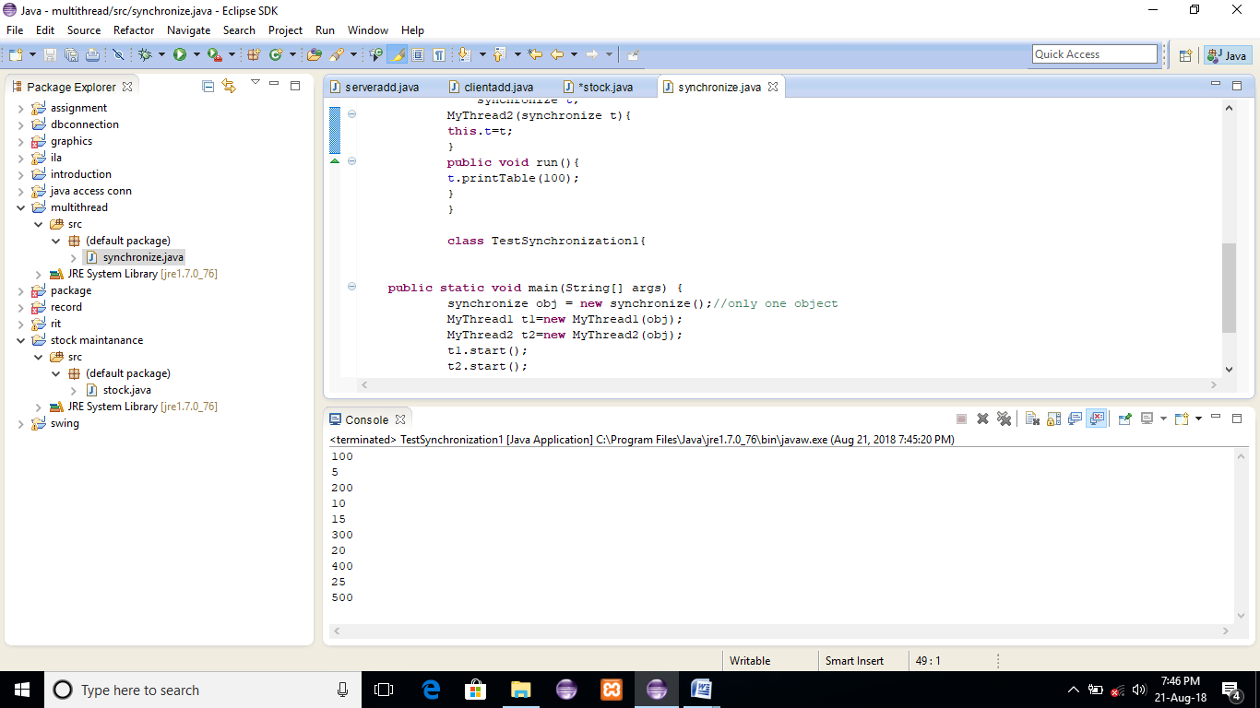

**RESULT:**